EXECUTIVE SUMMARY
The following is an expertly crafted Social media marketing plan for White Moon. The plan is broken down into five major parts. The parts are as follows social listening strategy, Content strategy, Website Recommendations, social media distribution plan, and an in-depth appendix. The sections are organized and found in the table of contents bellow.

Social listening strategy
We begin with the social listening strategy. We have prepared and executed a custom “social listening” strategy for White Moon. The strategy contains a baseline audit, Step-by-Step guide, and keyword audit. The baseline audit outlines what we’ve heard on the internet and social media platforms. It will serve as a foundation to guide White Moon through its own research & development. The Step-by-Step guide includes in depth instructions on how to conduct your own social listening strategy. Here we simplify the most crucial steps for success. Finally, we crafted a refined set of keywords. These keywords should serve as reference point in White Moons custom listening strategy. Feel free to use them as a base & add on from there.

Content strategy
The content strategy outlines how White Moon should craft compelling content. White Moons should be able to create long-term relationships around the notion of real communication and interaction. The content strategy includes a Publication schedule, Initial Content Repository, and Step-by-Step guide. The publication schedule is a diligently crafted schedule filled with ideas based around White Moons industry. We have included 8 months’ worth of content for White Moon to follow. The Initial Content Repository outlines specific content from the content schedule. We have created a blog containing the content we’ve created. The Step-By-Step guide explains how to craft the content. We cover blog, video, image, & audio creation. By following this section White Moon’s content will be a “thought leader” in their industry and drive social interaction.

Website Recommendations
Here we analyzed White Moons website. Our goal with this section is to simply the existing web presence of White Moon. The sections are divided into the following Search Engine Optimization (SEO) Overview, SEO Recommendations. Website/Code Audit, and Website Usability Audit. Search Engine Optimization is a brief introduction to what SEO is. Next, we cover SEO recommendations for improving White Moons “natural” SEO. The website/code audit provides recommendations for the current websites code. It details how the current code can be improved for successful SEO. We finish with White Moons website usability audit. This section includes best practices, tips for success, and a call-to-action plan. After reading this section White Moon should be able to create a website recommendations strategy based on improving SEO.

social media distribution plan
The social media distribution plan explains how to distribute content to social media. This section corresponds with the “social listening strategy” & “content strategy” sections. The distribution plan focuses on and provides best practice for distribution of White Moons content through specific social media platforms. The plan includes Recommended Social Media Platforms, Competitive Comparison, Step-by-Step Guidelines, and Objectives headlines. The recommended social media platforms headline details the importance of top social media platforms and their use case. We include the competitive comparison at the end of each social media platform. This serves as a look into what the competition is doing. Our step-by-step guideline shows White Moon how to create professional business accounts on respective platforms. We close the section by providing clear goals and objectives to strive for.

appendix
The last section serves as a hub for extra content. We included extra information for every section above. Look through the appendix to gain more insight on the sections covered. It is organized based on sections and is easy to navigate.

Table of Contents

SOCIAL LISTENING STRATEGY

Baseline Audit
Social listening is one of the most crucial elements to a successful marketing strategy. The initial ideas of marketing focused on telling customers instead of listening to them. Customers have become numb to traditional marketing and are more drawn to listening to everyday people in the marketing realm. Customers want to see others like them enjoying and benefitting from products to feel a personal connection to the advertisement. Marketing departments within companies are turning toward a more relevant and relational reputation among the customer base. Successful brands are learning to talk less and listen more.
Social listening comes in many forms. The most common are social media platforms and review sites. Social Media is so successful due to the human desire to share information with one another. Customers are more likely to engage with a brand that their peers have deemed as acceptable. Reviews and platforms allow customers to share their complaints, questions, and compliments for brands and services. The best information about the success of a brand is through the opinions of the employees and customers associated with the brand. Social listening can gather successes, failures, and areas of improvement. Another use for social listening is to compare the competition through their successes, differences, and similarities to your brand.

STEP-BY-STEP
The information below is comprised of research our team conducted to find out what customers are saying about White Moon and the respected industry. While we have provided a baseline audit of our information we found, we also included steps to continue the listening process yourself. Social listening is not a one-time action but is continuous and ever evolving as the wants and needs of customers change.

Our Initial Search

What Are Your Customers Saying?
The initial search of White Moon was on Google search engine and posts on social media platforms where White Moon was tagged, mentioned, or geolocated. These conversations provide valuable information on how to improve, explore new ideas, and increase brand awareness.

Keyword and Industry Search
Keywords are specific chains of words together that are consistently searched in search engines like Google and Bing. These keywords can be categorized by short tail or long tail. Short tail keywords are one or two keywords strung together that generate generic and broad searches. Long tail keywords are several words strung together resulting in more specific searches and information. Google Keyword Search is a search engine specific to keywords with details on their impact, cost, and amount searched with the ability for short or long tail keyword searches.

What Are Target Audiences Saying?
Even if customers do not mention White Moon by name, the conversations are still relevant to the business and industry. We conducted an initial glance at keywords related to White Moon to find trends and niches within the community and competition. What are customers saying about White Moon? Where are they located? Are they satisfied or unsatisfied? Did they mention anything about competition? Which competition are they mentioning? After answering these questions from our initial findings, we began to brainstorm a rough draft of keywords. These are called a seed list, that starts the process of listening before the specific keyword list blossoms. Google Keyword Search is a great place to start and even expand your keyword list based on Google’s suggestions.

Refining and Improving
We conducted a search through Instagram, Facebook, and Twitter with our seed list of keywords to find out if the keywords are actually relevant to White Moon and the brand industry. Testing out keywords is a beneficial way to consistently update and add on to your keyword list. Following our basic search, we refined and aligned keywords based on relevance and popularity. Keywords have infinite possibilities that might be useless, too broad, or even too specific for the goals of White Moon. Marketing is no longer just selling products and services but establishes a relationship with customers and audiences. Establishing those relationships comes from sharing information relevant and important to those audiences to show White Moon cares about the people they serve. Incorporating keywords that are relevant to your location, competition, and phrases used by target audiences will give you the information you need to give your audience content relevant to their interests.

Continue to Listen
We have created an account through Google Keyword Tool and Google Ads with the email whitemoonlistening@gmail.com to receive updates on keywords, phrases, and content related to White Moon to stay up to date on what audiences and customers are saying.

Recommendations

Who Should Be Listening?
Marketing managers should not be the only ones socially listening, or for those smaller businesses, one specific person. While there needs to be a manager in charge of the social listening, the team must be broad and potentially from different departments and skillsets. The variety of minds involved in social listening will promote a more diverse and engaged employee morale. The more eyes watching will increase the amount of content absorbed by the team and provides the ability to target specific needs of customers. Organization with larger teams includes the following actions:
- Access to the social media accounts for all team members. Establish a tone and a voice for White Moon for all team members to use when posting or responding to customers. Educate team members on appropriate responses, how to direct specific people to answer the diverse questions of customers, and what useful information to write down.
- Joint spreadsheets and documents to display keywords, phrases, and data. Joint spreadsheets organize information from each team member and provides a general guide to the required information. Visuals and examples in these documents will ensure the correct information is found and not overlooked. Decide on data, keywords, and phrases to focus on for all members. Address specific needs for individual members.
- Weekly meetings among members. Communication between the leader and the team members is key to successful agendas. Make sure to address team members’ questions, concerns, and ideas accordingly. This is a time for members to enhance their performance to ensure goals are satisfied in a timely manner.
- Use of a social media managing software. Social media monitoring software takes all social media accounts and places them on one simultaneous screen for easy viewing. Specific keywords or phrases can be monitored at once and receive alerts for desired data. We recommend using Hootsuite to watch Instagram, Facebook, and Twitter accounts for White Moon. We have created an account with the email whitemoonlistening@gmail.com and the password whitemoon2021. We have already connected the accounts and provided basic keyword searches to get you started with your initial data retrievals. As your goals change, so will your channels you watch. Through this channel you can send specific posts or direct messages from customers to individual team members with specific expertise.

Monitor Channels Everyday
Social listening can fluctuate and change daily, or even hourly. It is crucial to establish individual team goals so that information is not missed. Trends come and go, and customers are the first to know these changes. The following steps will produce relevant and consistent data for social listening:
  - Check Hootsuite channels. Watching posts, comments, tags, and direct messages daily will improve the relationship between customers and White Moon. This also ensures White Moon stays relevant to the public.
  - Give customers a chance to speak. Use social media to ask customers their opinion and make them feel they are impacting the brand directly through their responses. Coming out with a new drink? Ask their opinion. Wanting to have an event? Ask them which option they like best. Customers love to share their opinion, hence the review function for a lot of websites.
  - Check email inbox. Customers with questions or ideas will see your email on your website and want to have direct communication with you. Select a couple people to focus on monitoring the email to make sure the data is not neglected.
  - Check in on communities and niches. Communities have conversations with valuable data, so spend a few minutes each day to see what they are saying.

How to Respond
Setting aside several times easy day to respond to direct messages, posts, mentions, and tags to communicate directly with customers and establish strong relationships. Strive to respond within a few hours of the initial post time. White Moon responding to customers in a timely manner keeps you relevant and a high customer service reputation. Follow these tips to stay engaged with customers in responses:
- Develop your voice. There are four steps to developing your brand voice. Your voice should reflect your goals and values of White Moon. Purpose, character, language used, and tone are what makes a brand voice. White Moon is friendly, personal, fun, and engaging.
- Prioritize varying responses. Time is limited in the marketing world and that means not everyone will get a response from you. Prioritize the posts that include keywords and phrases, brand name, or directed specifically to White Moon. Complaints and questions are the most important. Compliments, positive reviews, and everything miscellaneous are next.
- Be humble. Thank the customers who give you good reviews and compliments. Apologize to the customers who leave negative reviews. A simple, “I’m sorry, [insert first name]” establishes credibility and more likely to convert the customer into a happy one.

Continue to Research
While your first social listening plan can be successful at the time, trends will fade, and new ones will replace them. It is crucial to remain relevant and standout to the industry. How will you continue to set yourself apart from other brands similar to yours? This question is a constant reminder to work hard for your customer base and listen to what they have to say. Update your keywords often, listen to conversations, develop new goals or change existing ones, and remain humble.

KEYWORDS
Throughout these different sections of keywords, you will find sections based on different influential patterns that are relevant to White Moon and your respected industry. Keywords are an efficient, and every evolving way to stay up to date on what your customers and audiences are saying about you, related to you, or how you compare. Listening to other keywords outside of the area of Sylva, North Carolina will provide a channel of information that can give insight to updates in the industry and various other aspects you can implement or stray away from depending on your goals for the brand and how you want to express White Moon.

Most Relevant to White Moon
The keywords below represent social listening for White Moon, competitors, and the coffee industry. Listening to these keywords on a daily basis provides a general overview of the conversations directly regarded to White Moon. These may change as new businesses are introduced and old ones fade away. The location settings were set in Western North Carolina and White Moon’s website was used as the domain filter. To continue revising these keywords that are most relevant to White Moon can be found on Google Keywords.
There are a few locations throughout Cullowhee and Sylva, North Carolina that present aesthetic similar to White Moon. This includes Hillside Grind located on Western Carolina University’s campus, and City Lights Café in downtown Sylva. Starbucks is located on WCU’s campus as well and poses as a competitor to White Moon because both coffee shops attract college students. Farmhouse is a relatively new coffee shop to the area that has a southern and modern vibe that is attracting college students.
Keyword | Competition Level | Searches Per Month
White moon | Low | 100-1K
City lights café | Low | 100-1K
Bar near me | Low | 100-1K
Coffee near me | Low | 100-1K
White moon coffee shop | Low | 10-100
White moon coffee | Low | 10-100
Dunkin | Low | 100-1K
Starbucks coffee | High | 10-100
Starbucks | Low | 1K-10K
Coffee shops near me | Low | 100-1K
Farmhouse | High | 100-1K
Farmhouse mercantile | Low | 10-100
Sylva nc | Low | 1K-10K
Restaurants in sylva nc | Low | 1K-10K
Wifi hotspots near me | High | 10-100
Free internet near me | Medium | 10-100

COFFEE SHOP INDUSTRY
Keyword | Competition | Avg. Monthly Searches
Coffee shop near me | Low | 100K-1M
Coffee near me | Low | 1M-10M
Barista coffee near me | High | 10-100
Coffee downtown | Low | 1K-10K
Café near me open now | Low | 100-1K

CONTENT STRATEGY
Content strategies are crucial for a business to ensure relationships between the brand and the public are maintained. Strategies save time and money and significantly improve the customer experience. White Moon can educate, connect, and establish more customers through consistent content related to the brand and customers' valued topics.

Why is a Content Strategy Important to White Moon?
White Moon has an established audience on Instagram and reviews on Yelp and Google. Achieve brand awareness through encouraging current customers to engage with the brand on social media and using those customers to share White Moon with their family and friends. White Moon will use Instagram as a primary source of communication, as well as Facebook and Twitter. Instagram provides functions called stories, polls, and reshares that add to the main post feed to engage customers with fresh and enticing content.
There are various types of content that White Moon can use to boost customer engagement, brand awareness, and form relationships. Content options are endless with videos, photos, blog posts, tweets, and more to showcase White Moon's drinks, food, and an aesthetic atmosphere.

How to Establish Goals

Thought Leader or Lead Generation?
The first step to identifying goals is to decide if the brand wants to be a thought leader or lead generation. Thought leader businesses use their platform to lead audiences with their content and establish their reputation for influential and factual information. Lead generation means the company is looking to grow its brand awareness and reach more audiences to create leads. Leads are audiences that have the potential to be customers.

Define Your Buyer Personas
A buyer persona is the descriptive identity of White Moon's audiences. To find this persona, ask questions about those engaging with the business. What are vital characteristics they possess together? What platform is best to reach them? What are their interests, demographics, hobbies?

White Moon Strengths
All brands have their strengths and weaknesses. Improve strengths through analyzing how they benefit the business. Why does White Moon stand out from other coffee shops and bars in the Western North Carolina area? How can White Moon use those strengths in content creation?

Guide to Goals
- What is White Moon's mission statement? Why is White Moon here?
- What are White Moon's target customers and their wants and needs from the business?
- How does White Moon meet those wants and needs?
- What is White Moon good at doing? What is White Moon struggling with?
- What sets White Moon apart from Dunkin and City Lights Café?

CONTENT SCHEDULE

August

Drink of the Month
WHITE MOON – FROZEN HOT CHOCOLATE WITH DARK CHOCOLATE DRIZZLE
DARK MOON – WATERMELON HAZE WITH TITO’S VODKA
- This series is about showcasing the talent of White Moon coworkers. Baristas are talented individuals who use creativity and knowledge about coffee and flavors to create pairings to make specialty drinks. Each month there will be a drink that is created by employees and is based on the season, time of year, and other factors that might be specific to current events in the world, nation, or even the local area of Sylva.
- These posts can turn mundane and routine every month, but that is why each post will consist of different elements like the photo of the drink and the captions surrounding it. Some drinks may be based on customer input and polls on social media platforms. Use creative and enlightening language to establish an easygoing tone.
- Keywords used in this series can be, “speakeasy,” “bar,” “hot chocolate,” “coffee shop,” “vodka,” and, “coffee.”

Back-to-School Backpack Drive
- Jackson County is known for community support through providing for the students in the area. Jackson County is home to several schools with children who struggle to have supplies for new school years. We recommend White Moon to host a back-to-school backpack drive for anonymous doners in the community to give school supplies during the first few weeks of August. The purpose of this drive is to raise awareness and educate customers through inspiring language and a personal tone.
- Community is vital to the county and especially the town of Sylva. Expressing concern and care for the education of the student population shows that White Moon is an active leader in the county. The school drive can raise money and supplies for students for the following items:

- Backpacks
- Pencils, mechanical and wooden
- Pens
- Sharpies
- Highlighters
- Dry erase markers
- Erasers
- Sticky notes
- Notebooks
- Packs of paper

- Keywords associated with these posts are, “school,” “fundraising,” “donations,” “backpack drive,” “new school year,” “community,” and, “White Moon.”

Customer Appreciation
- Customer appreciation gives customers a chance to tell you how they feel about your brand. They can enter to win by sharing a photo of them or of their drink. This provides an opportunity for more brand awareness surrounding White Moon caring about what the customer base is saying.
- Customers are one of the most valuable assets a brand has, because they are brutally honest about how your brand is performing. Honesty from your customers about your products, services, and operations will provide insight to how White Moon can improve. Are you curious about how successful the new drink is? Ask your customers, sit back, and listen. Active listening, as mentioned in the social listening section, provides a direct channel for White Moon to the customers. Giving them a voice will be highly appreciated and not go unnoticed. Use warm and fun language to amplify the personal tone of this post.
- Keywords included are, “customer appreciation,” “give back,” “white moon,” and, “coffee.”

Throwback Thursday: First Year of Business

- This series of throwback Thursday will consist of photos, videos, and quotes from owners, employees, and customers associated or directly related to the topic of the week. Throwback Thursday matters to your customers, because it shows the history of White Moon and how it became what it is today.
- Do not be afraid to dig deep in emotions and details about the process of the first year of business. What were some successes? What were some failures? How did that influence how White Moon is seen today? These are things that intrigue your customer base in a small town. Main Streets are special to every town and city, therefore take pride in your history – your customers sure do. The tone of this series is informative and humble.
- Keywords included are, “throwback Thursday,” “history,” “white moon,” and, historic sylva.”

Student Appreciation: Go On a Hike!
- This series of student appreciation is about boosting the morale and mental health awareness of students. White Moon is located close to Western Carolina University college campus, therefore a lot of students going through real life problems make up a good majority of White Moon’s customer base. Students are busy and stressed out so White Moon provides Wi-Fi and a quiet oasis to complete homework or take a brain break with friends. Use this to your advantage by grabbing their attention with activities they chose to go to Western for. Hiking is a good example. This post is meant to be informative, inspiring and personal.
- Share local hikes that everyone loves or articles about how to plan for hiking for those who might be interested.
- Keywords included are, “hiking,” “get outside,” “student appreciation,” “white moon,” “wcu,” “western,” “go cats,” and, “western carolina university.”

September

Drink of the Month
WHITE MOON – PUMPKIN SPICE LATTE WITH CHOCOLATE DRIZZLE AND CINNAMON
DARK MOON – FRENCH TOAST SHOT
- The September drinks of the month reflect the beginning of fall and how the leaves will begin to change during this time. The weather starts to cool off and the sweaters are brought out of retirement. Pumpkin spice lattes are a classic sign of the birth of fall in the mountains. French toast shots for Dark Moon represent the warm huzzy feeling shots give you after you drink them. The warm fuzzy feeling represents a sweater on a chilly fall day.
- Drinks of the month are a time to represent the talent of White Moon and the talent of the employees. Drinks reflect the personality of the coffee shop and can be fun for customers to take photos of or promote on their social media and tag White Moon. The new drinks every month entices new customers and also provides something refreshing and exciting to the menu for regulars. This series is creative and enlightening to establish an easygoing tone.
- Keywords included are, “PSL,” “pumpkin spice,” “fall, “it’s fall y’all,” “fall in the mountains,” “white moon,” “dark moon,” “coffee,” and, “shots.”

Labor Day
- Labor Day is celebrated in the USA for appreciation of hard work. As a country, we have a rich history of advocating for workers’ rights and now we have a weekend long celebration full of lake days, camping trips, consuming alcohol, and relaxing before returning to work. Show appreciation for customers and employees by providing family fun activity articles or facts about Labor Day. This is engaging with your audiences and showing them how they can enjoy their day off school and work.
- Lake Glenville and the Tuckaseegee River are local to the Sylva area and are common playgrounds among residents. Use these locations to promote White Moon and showcase their relevance to Labor Day fun. Use language that is savvy and engaging.
- Keywords included are, “labor day,” “lake days,” “tuck river,” “tubing,” “grill out,” “cookout,” “white moon,” “dark moon,” and, “get outside.”

Standout Employee:

[White Moon Insert Name Here] [Dark Moon Insert Name Here]
- Employees are another crucial asset to White Moon. Employees are the ones who operate your business daily, are interacting with customers, and serving your products. Customers receive first-hand feedback from customers and also have their own experience with how the company is succeeding or failing. Showing appreciation for employees shows you are a friendly, inviting, and loving atmosphere and take care of your workers.
- Appreciating your current employees publicly will boost the morale of the business, encourage them to stay and provide the best service to customers, and influence good candidates for future employees. Showcase the employees’ hobbies, interests, their best talent on the job, and any other cool facts that shows the personality and tone White Moon represents. This series is humble, whimsical, and warm.
- Keywords included are, “employee appreciation,” “staff appreciation,” “white moon,” “dark moon,” “white moon staff,’ “dark moon staff.”

First Day of Fall
- Coffee shops use significant changes in the weather to base their drink menu on. Cold months or seasons sell more hot drinks, while warm months and seasons sell more cold drinks. Fall is the tourist season for this area due to the gorgeous colors of leaved before they fall for winter. White Moon can use this tourist season to attract customers in the shop to purchase warm drinks to warm up the leaf admirers.
- Posts about fall can include, but not limited to, articles about fun activities to do in the mountains during the fall, the best sight-seeing locations for leaves, and various other activities to do while visiting like shops and other surrounding towns. These posts are meant to be educational and present a direct tone.
- Keywords included are, “first day of fall,” “fall in the mountains,” “beautiful leaves,” “leaves changing,” “sight-seeing,” “white moon,” “dark moon,” “western north Carolina,” “towns to visit in the nc mountains,” “best hikes for watching the leaves change,” and, “fun activities to do in wnc mountains.”

Student Appreciation: Follow the Leaves!
- Continuing the posts about fall, White Moon can use student appreciation week to share articles and content about fall, where to see the leaves, and various other activities to do in the town or surrounding towns. Lots of students choose Western for the various outdoors activities that present themselves for this area.
- Mental health is a big issue on college campuses due to the high stress and new environment. These students are learning to be independent and successful, so providing activities to enjoy their time here will benefit them and show that you care about their wellbeing. Hidden gems are the best in areas like Sylva. This tone is playful and informative.
- Keywords included are, “fall in the mountains,” “beautiful leaves,” “leaves changing,” “sight-seeing,” “white moon,” “dark moon,” “western north Carolina,” “towns to visit in the nc mountains,” “best hikes for watching the leaves change,” and, “fun activities to do in wnc mountains.”

October

Drink of the Month
WHITE MOON – SPOOKTACULAR SPIDER MOCHA
DARK MOON – WITCHES BREW
- October is the beginning of preparation for Halloween across the country. Starbucks is one of the first brands to showcase their spooky drinks for the season. We suggest a Halloween themed drink for White Moon and Dark Moon. These drinks will come into play with the Halloween costume party coming up closer toward Halloween.
- To keep up with the Starbucks on campus at WCU, we suggest White Moon provides a Halloween themed drink and Dark Moon has a Halloween themed beverage. The Spooktacular Spider Mocha will have chocolate drizzle on the sides of the cup, with blended espresso, milk of choice and then whipped cream. The garnish is a candy spider and a web drawn with chocolate on the whip cream. For Dark Moon the Witches Broom is a shot of vodka, raspberry syrup, sprite, and edible glitter. This tone is creative and enlightening.
- Keywords included are, “witches brew,” “Spooktacular,” “Halloween,” “spooky season,” “spider mocha,” “white moon,” and, “dark moon.”

White Moon & Mountain Mystic Collaboration
- White Moon has shown an appreciation and support for other small businesses in Sylva already, so this collaboration will further that expressed support. In a small town there are several ways to remain relevant and involved with the community. Small businesses that support other small businesses is a common expression among mom-and-pop shops.
- Mountain Mystic will table outside of White Moon for several hours during the course of a regular work week to educate White Moon employees about their products at Mountain Mystic. Mountain Mystic carries several stones and gems that represent different things. This is a play on the Halloween theme during October. The tone of this post is collaborative, inviting, and informing.
- Keywords included are, “mountain mystic,” “crystals,” “gems,” “white moon,” “dark moon,” and, “Halloween collab.”

Dark Moon Costume Party
- Young adults can attend this costume party. A bouncer will be present at the entry to check licenses and place an X on the hands of those under 21. Ages 18 and older are welcome to attend. Alcoholic beverages will be served, and a costume contest will take place throughout the event.
- The costume contest will have three categories. Couples’ costumes, individual costumes, and group costumes will be the categories everyone will vote on. Every person can vote for each category once. These posts are inviting and warm tones.
- Keywords included are, “costume party,” “speakeasy,” “bar,” “white moon,” “Halloween,” “cocktails,” “wine,” and, “Halloween events.”

Halloween
- Sylva kids do not have a lot of locations where they can safely trick-or-treat due to the lack of safe neighborhoods in the small town. Western Carolina University provides a safe environment for students to come dress up in costumes and receive candy. While this is a great event, more engagement would benefit White Moon and increase brand awareness.
- Allowing kids of all ages to come trick or treat with their parents during Dark Moon hours, the parents will be exposed to the speakeasy and coffee shop and consider returning once White Moon has established a reputation in their minds. Halloween posts are whimsical and fun.
- Keywords included are, “Halloween trick or treating,” “Halloween events,” “trick or treat,” “dark moon,” “white moon,” “Halloween,” and, “safe trick or treating.”

Student Appreciation: Pumpkin Patches in WNC!
- For this series the topic is pumpkin patches in Sylva and surrounding areas like Dillsboro, Bryson City, Waynesville, and Franklin. October is a great month for the perfect amount of cold weather and pumpkin patches are prevalent for the Halloween season.
- Pumpkin patches are a hub for several activities. Photos, picking pumpkins, some even have treats, apples, pies, and other stuff to buy. Some pumpkin patches have hayrides, like Darnell Farms in Bryson City that families love to go to. Informative and direct tones give clear intentions.
- Keywords included are “pumpkin patch,” “hayrides,” “white moon,” “photoshoot,” “Halloween,” “pumpkin carving,” and, “fun things to do in sylva nc.”

Pumpkin Carving
- All ages enjoy carving pumpkins for Halloween. We suggest sharing free printable faces for pumpkin carving, articles about the history of carving pumpkins, and maybe have a contest for customers to share their carved pumpkins online to be judged by White Moon.
- Families, especially with younger children, are active during Halloween with hayrides, pumpkin patches, carving them, picking out costumes, and having parties in school. Sharing this information expresses interest in customers’ lives and establishes brand personality. Pumpkin carving information is fun, whimsical, and informational.
- Keywords included are, “pumpkin carving,” “free pumpkin carving printables,” “diy pumpkin carving,” “pumpkin carving ideas,” “white moon,” “dark moon,” “how to carve a pumpkin,” and, “pumpkin patch near me.”

November

Drink of the Month
WHITE MOON – DIRTY CHAI WITH HAZELNUT FLAVORING
DARK MOON – SANGRIA WITH FRUIT GARNISH
- A dirty chai latte with hazelnut flavoring is the drink special for the month of November. A dirty chai latte is chai, milk, and two espresso shots and one pump of hazelnut. We chose this drink because chai gives a warm sensation as you drink, the steamed milk softens the nip of chai, the espresso adds a buzz and hazelnut provides a smooth aftertaste. If November was a drink, this would be it. Dark Moon will have sangria with fruit garnish because sangria is sweet and slightly bitter at the same time. This is a representation of the November weather with sunny days and a crisp breeze.
- Adding imagery in the descriptions for these drinks makes people picture what they are drinking as if it were happening right in front of their eyes. November is known for cold weather which means more hot drinks will be sold. Imagery and visuals are enticing and fun for customer engagement while also being memorable. The tone should be classy, direct, and informative.
- Keywords included are, “dirty chai,” “chai,” “white moon,” “espresso,” “dark moon,” “sangria,” and, “cold weather drinks.”

Veterans’ Day
- Veterans’ Day is celebrated across the nation and with Sylva being a rural area there are several veterans and supporters of military members. A simple celebratory post or thank you post for veterans shows appreciation for the military community. Showing this support will create brand awareness and pride for America.
- Countless lives have been lost fighting for our country and people of the Sylva take pride in that. Posts for holidays in general are a chance for brands to share their values and relate to customers on a relational level. Share history about veterans’ day, history of Sylva veterans, or even articles related to the holiday. The tone is direct, informative, and humble.
- Keywords included are, “veterans’ day,” “military,” “thank you,” “thank you for your service,” “white moon,” “dark moon,” and, “military appreciation.”

Standout Employee:

[White Moon Insert Name Here] [Dark Moon Insert Name Here]
- For this series two new employees (one from White Moon and one from Dark Moon) will be honored. Sharing information about these two people will showcase their talents, ambitions, hobbies, and any other fact about them that is expressive of the brand personality. White Moon cares about their customers and their employees.
- Building connections and relationships with customers is directly influenced by the interactions they have with employees. If the customer gets to know the staff through White Moon’s bragging, the more engaging and satisfied customers will feel. Use fun and simple language to convey a personal tone.
- Keywords related are, “employee appreciation,” “staff appreciation,” “white moon,” “dark moon,” “white moon staff,’ “dark moon staff.”

Happy Thanksgiving
- Thanksgiving is a time to celebrate what everyone is thankful for. White Moon cares about the customers and is thankful. A way to show that gratitude is to share a thank you to customers, articles about Thanksgiving history, fun games to play with the family at Thanksgiving, and recipes.
- These posts should be informative and also show gratitude for your customer base. The tone for the post will be direct and personal. Relationships are crucial in the world of business to consumer marketing.
- Keywords included are, “thanksgiving,” “recipes for thanksgiving,” “thanksgiving meal,” “what are you thankful for?” “white moon,” “dark moon,” and, “customer appreciation.”

Student Appreciation: Best Places to Watch a Sunset!
- Student appreciation is a series that encourages students to get outside, so this one consists of links to articles where the best places to watch a sunset are in Sylva and the surrounding areas. With the airport and the parkway nearby, western students are known for their constant trips to watch the sunset.
- The tone for this series is overall informative and humble, but this particular occurrence is fun and inviting.
- Keywords included are, “sunset,” “chasing the sun,” “Jackson county airport,” “blue ridge parkway,” “waterrock knob sunset,” “white moon loves sunsets,” “get outside,” “dark moon,” and, “student appreciation.”

December

Drink of the Month
WHITE MOON – MOCHA LATTE WITH PEPPERMINT CRUMBLE
DARK MOON – PINOT NOIR AND A HOLLY JOLLY JUICER
- These drinks are just in time for the holidays. Christmas and New Years are right around the corner, which means the peppermint and chocolate duo is making its annual debut. Mocha latte with peppermint crumble on top is Christmas and winter weather in a cup. Dark Moon is taking a classy approach to warm up with a nice glass of red wine and an edgy juicer with candy cane layers and a cherry garnish. These drinks will spice up the holidays and put a pep in the steps of customers.
- These drinks of the month are special – they have a spunky, playful, and whimsical tone. Offer some articles throughout the month about the best Christmas gifts and include gift cards from White Moon. Customers can pick up their gift cards while sipping on either specialty drink. Christmas shopping made easy.
- Keywords included are: “cold hands, warm heart,” “pinot noir,” “Christmas time,” “Christmas,” “white moon,” “dark moon,” “holly jolly juicer,” “peppermint mocha,” and “it’s the giving season.”

Throwback Thursday: Story about the Longest Working Employee to Date
- This occurrence in the throwback Thursday series will focus on the employee who has been working at White Moon the longest. This will include an employee from both White Moon and Dark Moon. The employee will share their story how they ended up at White Moon, the changes they have seen since the beginning of their experience, and any fun facts about the place that are considered “VIP access” that not all customers know.
- The tone of this occurrence is relaxed, informational, and fun. The post is intriguing and makes the customers feel they are getting the inside scoop on the history of White Moon.
- Keywords included are: “throwback Thursday,” “white moon,” “throwback,” “TBT,” “dark moon,” “VIP access,” “white moon secrets,” and, “oldie but goodie.”

Ugly Christmas Sweater Competition
- The ugly Christmas sweater competition is a way for customers to come together and showcase their talent. Throughout the weeks and days leading up to the competition White Moon can share the event details, the criteria, how to enter, the prizes, and the aftermath with the winners.
- The tone of this post is whimsical, relaxed, and enthusiastic. The competition is for a morale boost during the holiday season. Interactions with the customers of White Moon will keep your brand in mind when holiday shopping for others.
- Keywords included are, “ugly christmas sweater,” “christmas,” “holidays,” “holiday season,” “white moon,” “dark moon,” “competition,” and, “winner winner chicken dinner.”

Biking Trails in WNC You Can’t Miss
- White Moon attracts people who love to be outdoors and find new ways to explore the area. Whether college students, young kids, parents, adults, older people – anyone can be active outside. Several members of the community love to ride bikes and would be interested in finding out more information about trails they can ride on in the surrounding area.
- The tone of this post is to be informative and friendly. Customers want to read about events and ideas they care about. Active listening on social media and asking your customer base questions will give White Moon content ideas for future posts and campaigns.
- Keywords included are, “biking,” “bike trails,” “trails,” “white moon,” “dark moon,” “outdoors,” “get outside,” “wnc,” “wcu,” and, “wnc mountain trails.”

Student Appreciation: List of Hidden Gems in Bryson City, NC
- Students love to explore new restaurants, places to hike, lookouts, and really anything that is thrilling or fun. Small towns and their surrounding ones are full of hidden shops or restaurants that could use some love from young college students. Bryson City is full of breweries, restaurants, places to tube and hike, and even a farm with tons of seasonal elements.
- The intent of this series is to enlighten and show some love for the interests of college students. The tone is informative and inviting.
- Keywords included are, “white moon,” “dark moon,” “Bryson city nc,” “fun things to do in Bryson city,” “wcu,” “student appreciation,” “tubing,” “hidden gems,” and, wnc mountains.”

January

Drink of the Month
WHITE MOON – CAMPFIRE S’MORES LATTE
DARK MOON – SOUTHERN OLD FASHIONED
- January is a month that is full of resolutions and new hopes and dreams. In honor of the cold, and upbeat month the campfire s’mores latte and the southern old fashioned are the perfect way to bring in the new year. Some ideas of posts are of customers writing their resolutions on their cup of the drink special or on a white board during Dark Moon hours.
- The intent of this post is to provide a hopeful and encouraging tone. The drinks of the month represent what is going on throughout the month – hence the comforting choice in beverages.
- Keywords included are, “southern old fashioned,” “s’mores latte,” “white moon,” “dark moon,” “new year’s,” “resolutions,” “new year, new you,” and, “cheers.”

National Poetry Day
- In honor of the holiday and Dark Moon speakeasy, a post of a haiku or a poem saying how much white moon loves their customers would be fitting. A poetry night will be held during Dark Moon hours on the holiday.
- Some examples of this could be various favorite poems from employees and why. The tone of this content is to be informative, educational, fun, and professional.
- Keywords included are, “white moon,” “dark moon,” “national poetry day,” “poetry,” Haiku,” “favorite poems,” “speakeasy,” and, “poetry night.”

New Year’s Resolution
- Resolutions can be shared throughout the entire month of January but will be most popular the week before the new year and two weeks after. Encouraging posts and quotes can be shared to uplift those who are attempting a resolution.
- Some other examples of content are articles of habits to live a healthy life in the new year or the best resolutions of said year. Customers can continue to write their goals on their cup with sharpies provided in store for to-go orders or at home with the specialty drink. The tone is positive and charismatic.
- Keywords included are, “new year new me,” “resolution,” “drink special,” “white moon,” “dark moon,” and, “healthy lifestyle.”

Throwback Thursday: History of Sylva’s Main Street
- This occurrence in the throwback Thursday series will focus on the history of Sylva’s main street. The town of Sylva has a rich history. This occurrence can include old blueprints of the street, old photos of previous businesses, and especially old businesses from where White Moon is now located.
- The tone of this occurrence is informative, honest, and accurate. The history is important and should have extensive research behind any claims made by White Moon.
- Keywords included area, “throwback Thursday,” “TBT,” “white moon,” “dark moon,” “main street,” “sylva nc history,” “sylva main street,” and, “historic downtown.”

Student Appreciation: 5 Best Breweries in Sylva
- College students love to spend time together and drink beer like it is bottomless. While promoting other breweries, White Moon will gain brand awareness for Dark Moon by being generous with social media real estate. Small businesses in Sylva have each other’s back and want each other to succeed as much as they want themselves to be successful.
- The tone of this occurrence is informative, relaxed, and friendly.
- Keywords included are, “student appreciation,” “wcu students,” “students,” “best breweries,” “breweries,” “craft draft beer,” “draft beer,” “white moon,” “dark moon,” “speakeasy,” and, “sylva nc.”

February

Drink of the Month
WHITE MOON – I LOVE YOU BERRY MUCH WHITE CHOCOLATE LATTE
DARK MOON – LOVE ON THE BEACH
- This occurrence is to celebrate the popular holiday Valentine’s Day. The White Moon specialty drink is a white chocolate mocha with raspberry flavoring. The pretty pink color matches the theme of red and pink that is associated with the holiday. Dark Moon has a classy take to Sex on the Beach but is called Love on the Beach. This is a dark red color with a strawberry garnish.
- The intent of this is to encourage customers to take photos during the month with their drink dressed up or with their significant other. Photoshoots in the shop will create brand awareness when the customers share them with friends and family. The tone will be supportive, direct, and relaxed.
- Keywords included are, “valentine’s day,” “February 14th,” “white moon,” “dark moon,” “specialty drink,” “drink of the month,” “I love you berry much,” and, “love on the beach.”

Valentine’s Day
- Content for this holiday can include articles on the best dishes to make for two, best places to eat in Sylva for two, what type of wine goes with what type of meal, best valentine’s gifts for him or for her, and anything surrounding the holiday. This content can last for the two weeks leading up to the holiday.
- The tone of this post is relaxed, informative, and precise.
- Keywords included are, “Valentine’s day,” “recipes for two,” “wine 101,” “white moon,” “dark moon,” and, “cupid.”

Black History Month
- This content will consist of several posts throughout the month. Articles of history of the culture, rights movement, fashion, and famous quotes from influencers can be informational and enlightening to the White Moon community.
- The tone of this content will be very poised, precise, scientific, and compassionate.
- Keywords included are, “black history month,” “justice,” “peace,” “martin luther king jr,” “MLK,” “I have a dream,” “black history,” “white moon,” and, “dark moon.”

10 Plants You Need in Your Home
- An article about plants that are beneficial to the everyday household will be appreciated by the customers and reflect the personality of White Moon. White Moon has several plants and some of the ones in the shop will be in the article that customers will recognize.
- The tone of this article is whimsical, educational, and friendly.
- Keywords included are, “white moon,” “dark moon,” “best house plants,” “plant mom,” and, “plant dad.”

Student Appreciation: Best Coffee Makers for College
- Sometimes college students do not have time to drive from campus to White Moon. Sharing a good list of coffee makers with customers will not cause them to not need you anymore but will show understanding of money being tight and schedules crammed full.
- The tone of this post is neutral and informative.
- Keywords included are, “student appreciation,” “coffee,” “espresso,” “latte,” “white moon,” “dark moon,” “wnc,” and, “college life.”

March

Drink of the Month
WHITE MOON – LUCKY TO HAVE YOU BLENDED COFFEE
DARK MOON – JIM BEAM SHOTS
- March is known for mixed weather in the town of Sylva. Some days are muggy and rainy, while other days might have freezing temperatures at night. These drinks of the month will spice up the series with a Lucky to Have You blended coffee to cool off customers during the muggy days, but Jim Beam shots to warm them up during the freezing cold nights at Dark Moon.
- The tone of this occurrence is friendly, inviting, and charismatic. Saint Patrick’s Day in the USA has turned into celebrating with everything green and blaming mischievous acts on little invisible leprechauns – so why can’t White Moon do the same? Go for a mischievous and clever take on language.
- Keywords included are, “st patty,” “saint patricks day,” “white moon,” “dark moon,” “drink special,” “everything green,” “leprechauns,” and, “jim beam.”

Women’s History Month
- Women’s History month is a celebratory ode to the hardworking women that make this world go ‘round. Share articles about the history of female rights in America or even have interactive discussions. Ask your customers who the most influential woman is in their lives and why? Maybe even ask them for their favorite quotes from women.
- The tone of these posts will be educational and scientific throughout the entire month. Sharing serious and factual content like Women’s History month must be presented in a credible manner to maintain a positive reputation with your customer base.
- Keywords included are, “women,” “womens history month,” “empowered women empower women,” “women rule,” “thank you,” “white moon,” and, “dark moon.”

Saint Patrick’s Day
- This holiday is a celebration full of green themed items and fun activities – including drinking. These posts can be about the history of the holiday and how it became a tradition. Fun facts and articles about fun activities to participate in will give customers the ability to interact with White Moon and build rapport.
- The tone of these posts will be whimsical, intellectual, relaxed, and some can be scientific. The possibilities are endless.
- Keywords included are, “st patty,” “saint patricks day,” “white moon,” “dark moon,” “drink special,” “everything green,” “leprechauns,” “jim beam,” and, “kiss me I am irish.”

Throwback Thursday: Q & A
- This occurrence in the series is called a question and answer. The point of the posts is to give customers the opportunity to ask White Moon what they want to know about the history of the company. This could include building related questions, personal questions about the White Moon owners and staff, or even about the new market that is being opened up by you. The options are endless, giving customers the control while also creating brand awareness they can share to their friends.
- The tone of this occurrence will be diverse to include the various aspects that can step from what the customers ask. The tone could range from scientific, relaxed, fun, whimsical, and even intellectual.
- Keywords included are, “white moon,” “dark moon,” “history of white moon,” “q&a,” “question and answer,” “q&a panel,” “TBT,” and, “throwback Thursday.”

Student Appreciation: Best Ice Cream Shops in WNC
- While Jack the Dipper is a popular choice for ice cream needs among the area, college students love to find new places to explore. So why not with ice cream? Articles about ice cream places, locations, and even contact information for these places can be enlightening and exciting for the college students.
- The tone of this occurrence is fun, relaxed, and inviting. Who can turn down ice cream?
- Keywords included are, “student appreciation,” “wcu students, “go cats, “cats by 90,” “jack the dipper,” “jack,” “wcu,” “wnc,” “sylva nc,” “best ice cream,” “white moon,” “dark moon,” and, “rip campus scoops.”

CONTENT REPOSITORY
Examples The content repository highlights six pieces of content capture from the content strategy schedule. The six articles can be found on Squarespace. https://pomegranate-wolverine yzw8.squarespace.com/config/.
- Login Traekanupp@gmail.com
- Password: whitemoon406
Make sure to keep the login secure. Only give the blog login to trusted employees who are authorized to post on behalf of the company.
- Each article has three pictures, and four of the six articles have video links.
- Each article has been posted in the blog section
- Each video and audio link is embedded in the blog

FIRST DAY OF FALL
Headline: Welcome to Fall, Y'all!
Text: Customer interaction is something you should take seriously. One way to do this is by doing a seasonal poll on your Facebook or Instagram. We recommend this poll to be posted on September 22, 2021 and the poll will last for 24 hours. We are doing this poll at the start of fall because most of our customers will be in the area since college class will be in session. We think for fall you should create a poll that simply ask your followers, "What is your favorite thing about the season". Some customers may response stating their favorite fall drinks, and you could give you can idea of something new you could add to your menu. If you get enough response, you could create a new poll asking what fall items your customers would like to see on the menu. One response you may get is about the leaves changing colors especially being located in western Carolina. You could reply simply by saying you are excited for them to explore the new flavors that are available during this time of the year. Another reply you may receive is talking about the holidays that take place in the fall. You could response with something along the lines of, make sure you follow us on social media to see what we offer on those holidays. You could use this as an opportunity to post your holiday hours. This option would be exclusive for Instagram, and on Instagram you can ask the open-ended question with hopes of getting a detailed response. Instagram allows you to share responses you have received by replying to your followers and gives you the chance to weed out any negative comments. This feature is exclusive to Instagram, and on Facebook you would have to create a poll asking a yes or no question. We suggest that you ask something along the lines of "Is fall your favorite season." The purpose of doing a poll on social media allows you to interact and strengthen your relationship with your existing customers. Although, it is important to have customer interaction in general, you should also take note of what your competitors are doing in many fashions. Since you competitors do use their social media platforms to interact with their customers, we think you should do the same. We believe you can stay active on social media but having different staff member create a poll or post biweekly to further engage with customers.

KEYWORDS & PHOTOS
Keywords: competitors, poll, interact, engage


BACK-TO-SCHOOL DRIVE
Headline: Jackson County Back- to-school drive!
Text: White moon would benefit from a public-school drive that would be giving back to the community. Community outlook is extremely important because it shows the community you have a social responsibly to upkeep. We are choosing to do this during the month of august because this is when school is opening back up and some of the community may be struggling to get some supplies because of covid. Because of COVID- 19 some students are struggling financially to purchase supplies they will need for the school year. This is an important event for white moon to host as a way to get word of mouth advertising and creating a positive reputation for themselves. It is important to have a positive reputation but not just in name through your actions as well for events like this. With White Moon hosting this event, it shows the community that they care about their local students in Jackson County. Throughout the duration of this event, white moon will benefit from the influx of this foot traffic and new potential customers that have figured out where White Moon Coffee Shop is located. If you are a parent or guardian of a K-12 student, you can go to White Moon on Tuesday August 3rd through Thursday August 5th and pick up your supplies that will be distributed based on your child's grade level. This drive will be held over the course of 3 days. Tuesday August 3rd will be for K-5 students and will take place from 8am to 3pm. Any student in grades 6-8th can attend on Wednesday, august 4h from 8am to 3pm. Any high school student in grades 9-12th can attend on Thursday, August 5th from 8am to 3pm. For those who have never been, White Moon Coffee shop is located in downtown Sylva between Tuckaseegee Fly Shop and Harry Alter Books on W. Mainstreet. In term of parking, guest can park either in the limited parking spaces in front of the coffee shop or in the available gravel parking lot that is less than a mile away. In order to get 10% off your next order take a picture of yourself with the supplies you donated at the drive and tag @Whitemoonsylva in your Instagram and "White Moon" on your Facebook post. This post should include a picture of your face as well as the supplies you donated. After you post you picture, White Moon will then direct message you back a link to a barcode that can be printed out if needed. The link will include your coupon of 10% for your next order that will expire after one use. Some of the school supplies you can donate are new backpacks, markers, crayons, pencils, paper, binders, and hand sanitizer. All of these supplies can be purchased at any local retail store in Sylva. Or they can be purchased online if supplies at the local retail stores are limited. We can't wait to see you there for the benefit of our students in the county.

KEYWORDS & PHOTOS/VIDEO


Keywords: Jackson county public schools, community, Sylva, donating
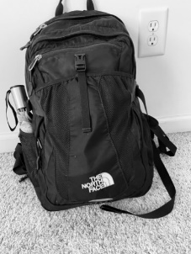
https://youtu.be/tz75goLVoAU

COSTUME PARTY
Headline: Get Spooky with White Moon
Text: On Halloween Day, White Moon Coffee Shop with be hosting a truck or treat event during White Moon Hours and an Adult Costume party during Dark Moon Hours. The event for the children will be truck or treat event and be held from 8am to 3pm. We expect children ages 12 and under to attend with their parents or legal guardians. Children are encouraged to arrive in their favorite Halloween costumes. White Moon Coffee shop will have a few different stations setup that children can visit for treats, as well as items for the parents or guardians. The treats for children will include a station where the children will receive lollipops of some sort. Another station for the children will have chocolate of some sort such as Reese's, Kit-Kats, and Milky Ways. The third station will be a photobooth set up by White Moon that will include a backdrop of White Moons Logo but also have picture props that children can use. We included this station solely to encourage visitors to take a picture while at the event and potentially post on their own social media platforms. The fourth and final station will have fruit snacks or gummies and a coupon for the parents to get a free drink. Every hour the White Moon staff will collaborate to discuss which costume was the best and that child will get a White Moon sticker. Overall. White Moon would benefit from this event by establishing themselves as a coffee shop that is not only kid friendly but also adult exclusive (Dark Moon). Although, both events will have a Halloween theme, the White Moon event will be suited more so for children in terms of the decorations use. For example, cut out pumpkins, pictures of Casper taped onto the walls, and fake bats hanging from the ceilings. In contrast, Dark Moon event will have scarier decorations such as dimmed lighting, tomb stones places throughout, and staff members dressed in "dark" costumes. For any individual that is 21 years or older there will be an event at Dark Moon on Halloween Night from 5pm-11pm. It is highly recommended that people attending the Dark Moon event come dressed in their best Halloween costume. For those dressed up a coupon for one free cocktail drink will be given. Additionally, the person the best costume will be awarded a White Moon water bottle. This event will be used as a way for people to interact while purchasing cocktails for the evening. We will also have a same photobooth that was available during White Moons event the same day to encourage the older crowd to talk about the event on their social media platforms. We anticipant this event being more so for Western Carolina College students. Dark Moon will benefit from this event by attracting college students looking for a discount for alcohol in the area. Although, Dark Moon has many competitors in downtown Sylva this is a way for you to attract the college students in the area that make up for a lot of the business the local Brewing's get. This will allow for Dark Moon to gain more recognition as a cocktail bar in downtown Sylva. Dark Moon isn't as popular as its counterpart White Moon and that is why we think it's important to incorporate Dark Moon in the content arcs we are delivering to you.

KEYWORDS & PHOTOS/VIDEO/AUDIO



Keywords: WCU students, treats, Halloween, costume party
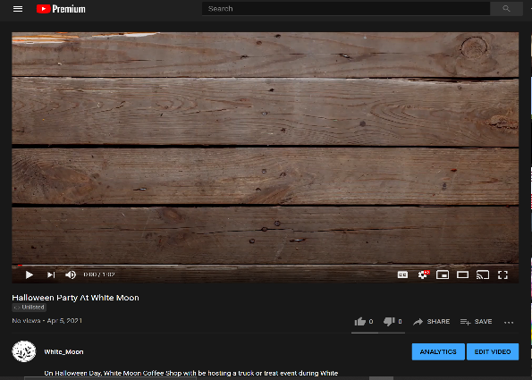
https://youtu.be/mETMgiGpP6A
The raw audio can be found here
https://soundcloud.com/sebastian-hernandez-214402541/white-moon-halloween-party/s-VsQJkrdiUDK
https://soundcloud.com/sebastian-hernandez-214402541/costume-party-at-white-moon/s-mViT2o6spdE

DRINK OF THE MONTH
Headline: Drink of the Month!
Text: Each month White Moon Coffee Shop and Dark Moon will promote a staff selected drink to the customers. For this special, we have decided to choose a cold beverage that would be refreshing for the warmest part of the year. These drinks will be advertised for the duration of the month. White Moon Coffee shop would be a great spot to spend a summer afternoon because not only is it pet-friendly, but it has a great outdoor seating area for customers to utilize. This promotion will be used as a way to bring existing customer and new potential customers to the downtown Sylva area. White Moon Coffee shop can use this opportunity to promote some of their less popular drinks, as well as any new beverages they have coming. For the month of August, we suggest White Moon Coffee shop to advertise their frozen hot chocolate, and their botanical Lemonade for Dark Moon. We suggest the frozen hot chocolate for the month of august because it is a very simple drink to make with very few ingredients. If this promotion leads to a lot of foot traffic, hopefully you will be able to serve it in a fast manner because it is a simple beverage to make. This drink will be available for everyone regarding there lactose tolerance since there is a variety of milk that can be used. For example, almond milk. For Dark Moon customer, we believe botanical Lemonade is a good choose because who doesn't love a refreshing lemonade on a hot summer day. This drink consists of 3 simple ingredient such as Gin, Saint Germaine, and Herbal botanical Lemonade. Like mentioned previously, because this drink contains three ingredients it will be able to be made in a fast manner in case of a high demand of customers. When it comes to advertising you can promote both of these drinks on Instagram, and Facebook including images of the beverages with a caption stating it is the drink of the month. It is important when posting on social media you include #Drinkofthemonth, #WhiteMoonSyvla, #DarkMoon. Using these hashtags can help spread the word of the special to not only customers but also to locals. Your social media posts don't have to end there, you can use this to also promote your online order option as well. With the online order option, customers can select a time and data that works best for them to pick up any drink. Although, this is a great feature for the coffee shop drinks, the online order would not be an option for the Dark Moon beverage as we cannot serve alcohol to go. This will especially appeal to your customers because of COVID-19 and all the safety precautions that comes along with that. You can also assure customers that the safety of yourselves and customers are being taken into perspective, you require anyone entering the coffee shop to wear a mask or be vaccinated. For those who are vaccinated they should be able to show proof using their ID as well as their vaccine card.

KEYWORDS & PHOTOS/VIDEO



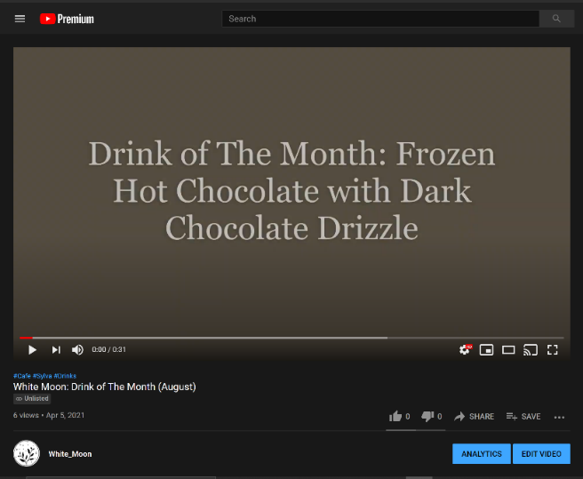
Keywords: Refreshing, Cold beverages, Pet friendly coffee shop, coffee shop with outdoor seating.

https://www.youtube.com/watch?v=SKaHYQBsal8

STAND OUT EMPLOYEE
Headline: White Moon's Standout Employee!
Text: It is important to recognize employees' hard work and dedication. White Moon Coffee Shop managers will select an employee each month that they believe has exceeded the expectations of their daily duties. This could include upselling products or engaging with customers as soon as they walk inside. Your managers should reveal their standout employee at the end of every month. Employee recognition incentivizes your team to work harder and understand that they are valued. The more appreciation they receive increases their likelihood of wanting to continue employment with your company. Employee retention will improve your staff's ability to be expert baristas. They will also become advocates of your business motto. All of these benefits of an employee appreciation program will help eliminate the number of workplace errors. This will also improve business flow and customer satisfaction. The business as a whole will thrive off of the positive environment and family like culture. Having a workplace where employees are comfortable with each other and trust your management team is essential. Your coffee shop will not only have excellent customer service, but the customers will feel important and start building strong relationships with your employees. It is important that customers feel welcomed and relaxed as they walk into White Moon. We suggest that White Moon posts their employee of the month on your Instagram, and Facebook profiles with a picture or video of the employee with their favorite menu item. With this post, you should include a brief description of the employees' background and the reasoning behind the recognition. You can create these posts for your social media via a story or you can post them in a form of a video introducing the staff member. In the post, you should be sure to include the reasoning behind this recognition. Although using social media platforms has become the social norm you should not forget the small customer base that include the older generations. You can reach this target audience by having an area in your coffee shop designated to post your employee of the month bio. For example, you could use a bulletin board. Another way for your customers to acknowledge the standout employees would be to provide the staff member with a pin to wear as part of their uniform that symbolizes excellent service. Adding this draws attention to the employee themselves as well as creating positive interaction that sparks conversation between your guest and employees. Due to this recognition, White Moon will show the community of Sylva they care and value their employees and their commitment. You can benefit from adding this award into your monthly recognition employee training. A way you can set this up is by allowing your customers access to nominate the employee of the month by provide examples of how the barista exceeded their expectations. Another way to obtain feedback is through their peers or fellow employees. Providing a way for the employees to recognize each other promotes team building and positive work cultures. A benefit that White Moon will receive from this is consistency in the relationship with the customers and employee. Customers will come in everyday and interact with a few of their favorite staff members. Overall, your employees are what help your business run, therefore recognizing them for their outstanding work is crucial.

KEYWORDS & PHOTOS/VIDEO
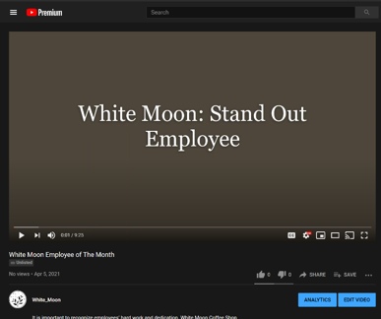


Keywords: employee appreciation, great customer service, community of Sylva, recognition

BLACK HISTORY MONTH
Headline: White Moon Coffee Shop should show they care about all their customers. One way they can show this by celebrating black history month.
Text: There are many ways to celebrate black history month. White Moon Coffee Shop celebrates by researching black historical figures/activists from North Carolina and posting about them weekly for the month of February. This would not only show your support for black history month, but that you've also done the research. A somewhat similar way you can celebrate the month is by having prints of activists pinned on your shop's walls, with a little excerpt on who the activist was and their notable actions. This would directly inform any of your customers that took the time to read these flyers. Another simple way you can promote the month is by posting a list of books people should read to learn more about Black History on social media. Another way you can celebrate Black History month is by promoting any events hosted by the local universities on your social media platforms. There will surely be events either hosted by WCU's Black Student Union, Intercultural Affairs office, and/or UNCA's Black Student Association. Since you all have hosted musicians in the past before, during Black History month you could host Black musicians and/or poets to perform throughout the month. You could find these musicians by reaching out to the music fraternities/organizations at the local universities. Speaking of universities, you could donate to a scholarship that will benefit a Black undergraduate student. Then follow that donation with a social media post listing instruction on how Black students can apply for the scholarship. If White Moon Coffee Shop promoted one of the listed organizations' events, you would likely see an influx of foot traffic from students that are members of the organizations and just black students in general. White Moon Coffee Shop could also reach out to these organizations to see if they'd like to host any of their in-person meetings in the coffee shop at least during the month. This could be helpful in showing more students where White Moon Coffee Shop is physically located, and it could lead to other organizations asking to host events at the coffee shop. If they enjoy the atmosphere and/or any drinks they purchase during their meetings you can easily turn them into loyal customers. Although we listed many different ideas White Moon Coffee Shop simply doing a few of the ideas listed for Black History month will greatly help their reputation with the black community in the Cullowhee/Sylva area. All of the ideas to show your support for Black History month we suggested can be shown on your social media. This is important to show your followers that these are your beliefs, and the caption should say something along these lines as well. A simple caption talking about the importance of Black History month should suffice and come across as genuine. Some businesses are weary of making these kinds of posts to avoid getting political, but it would be easy to show your support for all of the citizens of Sylva without alluding to a potentially polarizing political stance.

KEYWORDS & PHOTOS


Keywords: Black Student Union, Black History, Foot Traffic



STEP-BY-STEP

Blog
Blogs are a great way to become a thought leader within your customer base. Blogs serve as educational about your industry, build community, and attract prospective customers. Blogs can be used as heavy or as little necessary for the business as it relates to your goals. White Moon must keep a routine of content whether a consistent source for customers or an occasional source of information. There are many websites and brands to create a blog, and we have chosen to show you how to use Squarespace.

Website to use
Square Space is a beginner friendly platform used by small business owners, artists, photographers, and several other entrepreneurs like White Moon. Square Space offers website templates to get started with a basic blog feature and domain options. Their brand offers creative minds a platform to share stories and engage with customers to create beautiful relationships.

Accessing the blog
White Moons blog example can be found here https://pomegranate-wolverine-yzw8.squarespace.com/config/. Use login Traekanupp@gmail.com & Password: whitemoon406
Make sure to keep the login secure. Only give the blog login to trusted employees who are authorized to post on behalf of the company.

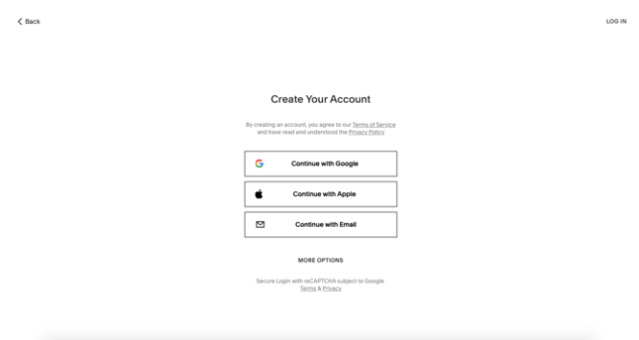
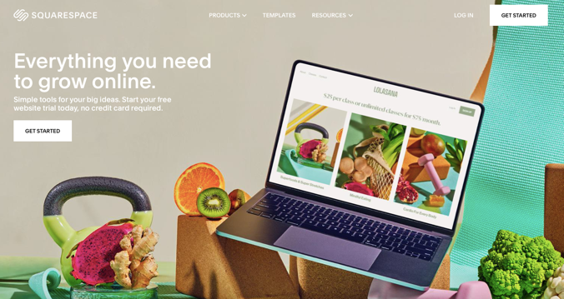
How to Set Up a Blog
Figure 2 Figure 3
- First, go to the blog set-up page on Squarespace on a desktop to begin.
- Create an account to save any templates used by clicking "Log In," as seen in the upper right corner of Figure 1.
- On the next page, as seen in Figure 2, there is a place to click "Create Account" in the upper right corner. This will prompt you to create a username, password, and email address, preferably with White Moon information and not personal information.
- Once logged in, you are ready to create your blog website. Squarespace makes the process easy to create a website with several templates to choose from. Figure 3 provides a small sample of the templates Squarespace provides. However, the one we believe to be a good fit for White Moon is called Hester as seen in Figure 4 at the bottom. The design is created for blogging, small businesses, and food.
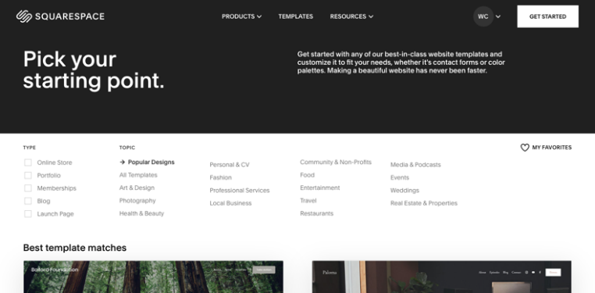
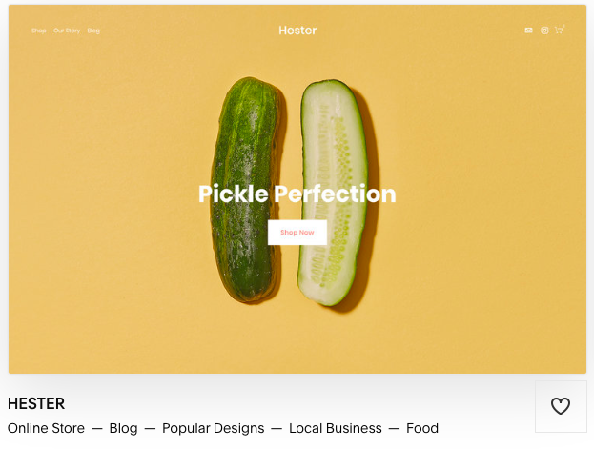

How to customize the blog
Squarespace shows you how to name, edit, and create pages once a template is chosen. Customization of the blog is a key factor in how the personality of White Moon will be presented. To customize, add photos that accurately reflect White Moon and Dark Moon. Preferably, original content taken from the business or relates to the industry. Content posts can include links, videos, photos, and various other tools to share quality content for all White Moon audiences. Figures 5 through 8 show the steps Squarespace provides to begin customizing your blog. Squarespace provides an introduction assistant guide to check all the necessary boxes before launching the blog. Site title or logo, add or delete pages, change fonts and colors, add images, and connect and update domains are all steps recommended by the beginner assistant before launching the website.
Squarespace has built in search engine optimization (SEO) tools at your disposal to start reaching a larger market. Figure 9 shows the steps to start optimizing the SEOs. Once you get to the page, there is a checklist to make sure you are getting the most out of the website and other features that will help White Moon reach more potential customers. When the website is completed, White Moon will pick a plan which best fits the brand. We suggest the business plan is $18 a month. This plan is the most popular, which includes various features to help the website appear modern and maintained. Finally, look over the checklist provided once more before the final launch.
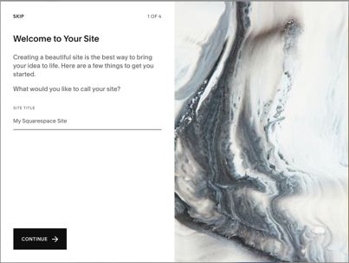
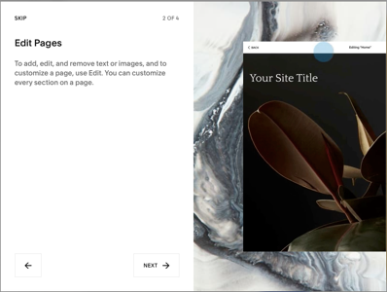

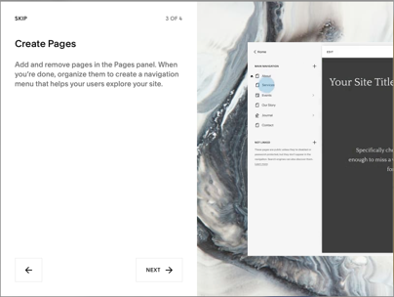
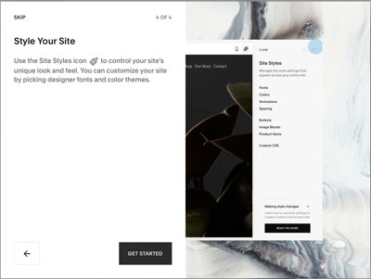

- Go to the home page of the new website and click the "edit" tab in the upper left corner, as seen in Figure 10.
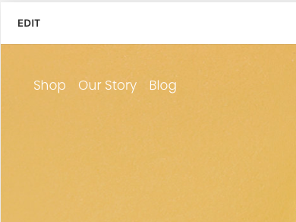
- Squarespace makes it very easy for users to add pictures and videos to the website. Go to the section of the webpage you want to embed the picture or video and hit the edit section. This tab will come up and you can add either a picture by uploading it or a video by clicking the YouTube link. Using the link to White Moon's YouTube profile creates traffic from the website to the video.
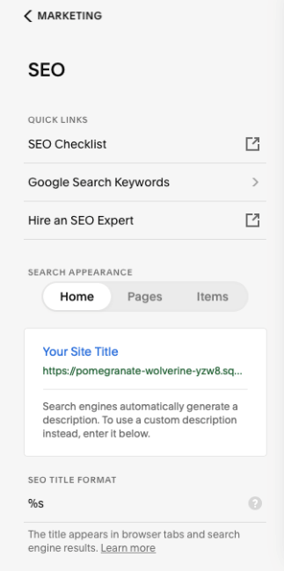
- Once a photo or video is added to the desired page of the website, customization of the appearance may be necessary.

FIGURE 9 FIGURE 10

How to creatE, edit AND PUBLISH a post

- When you click edit in the upper left corner, seen in Figure 10, you can access the blog portion of the website.
- Once in edit mode and on the blog page, click manage posts. This will showcase a page of all the pre-existing blog posts and the ability to add more. Figure 11 shows the blog manager and the plus sign to create a new post.
- After clicking the plus sign seen in Figure 11, a draft will open up for a new blog post that includes the title of the blog and the text box. An example has been shown in Figure 12 for reference.
- To add a thumbnail photo for a blog post, go to the blog title on the edit page from Figure 11 and click the three dots. The dots will bring up the options for settings, duplicate, or delete. Figure 13 shows the settings and to click on images. Drop or upload a photograph to the section provided.
- Click save when the cover photo for the blog post, title, and content are completed.
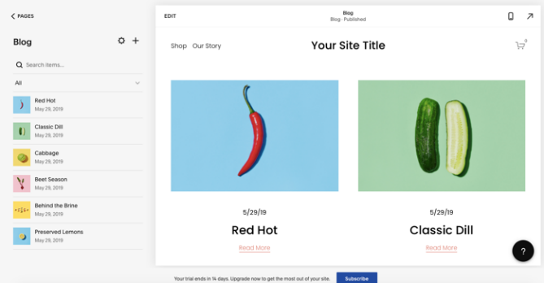
- Return to the blog post to click done as seen in the upper left corner of Figure 12. A menu will open, and you will click publish when satisfied.
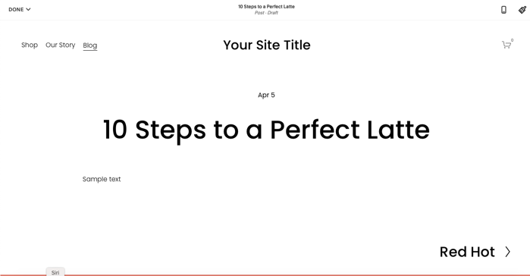
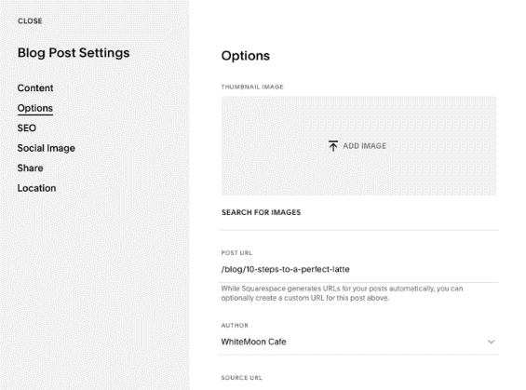

How to embed video, text, audio
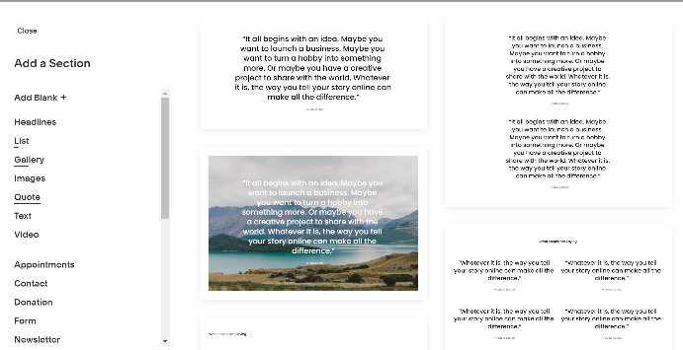
Embedding video, text, and audio is very simple on Squarespace.
- Start by adding a section. Here you can see all the different headlines available.
- Once you selected the content type it will make a section on the blog. See Figure 15.
- Once the section is added click on the content box to insert a link. See Figure 16.
- Check the post by clicking the link

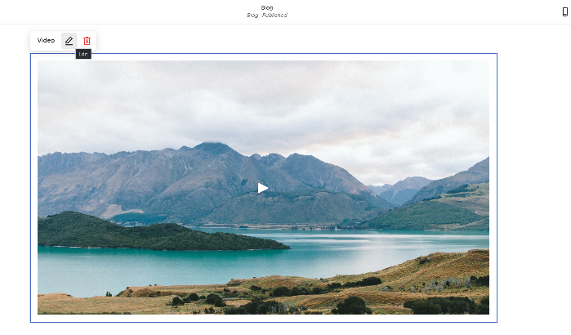
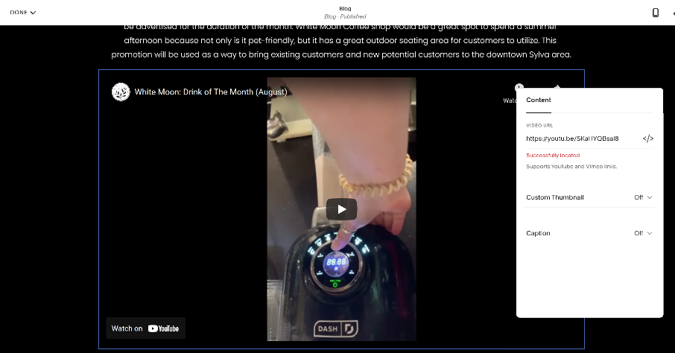

Short-Cut method
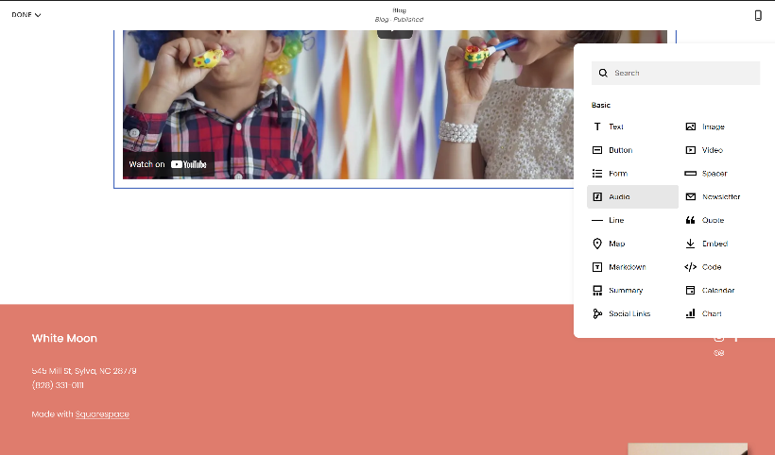
If you already have a section added you can easily embed links using these steps.
- Use the drop-down menu to select content type
- Select content such as audio. See Figure 17.
- Insert the link and describe the audio/content. See Figure 18.
- Check the post by clicking on the link

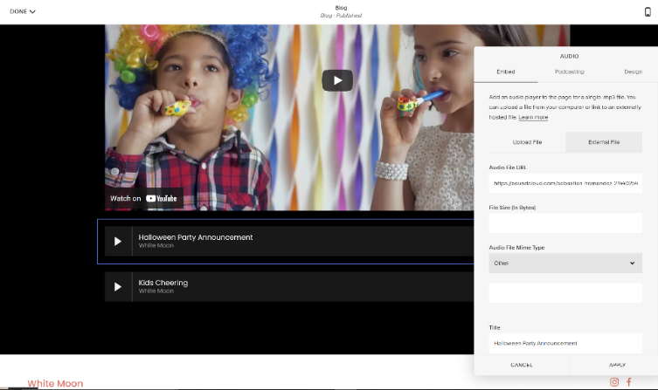

How to Upload a Youtube Video
Step One: Navigate to YouTube in your internet browser.
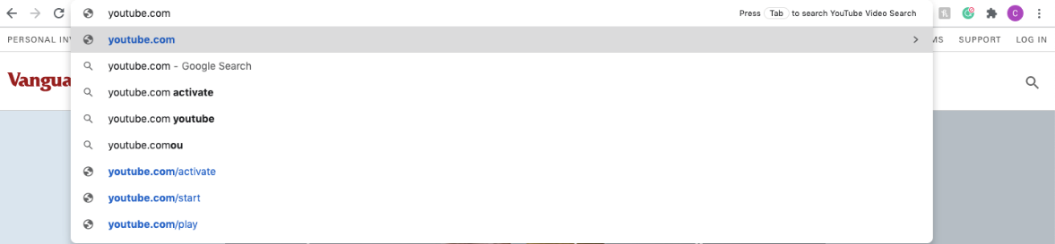

Step Two: Assure that you have an account and are logged into it, if you are not click "Sign In" in the top right corner to do so.
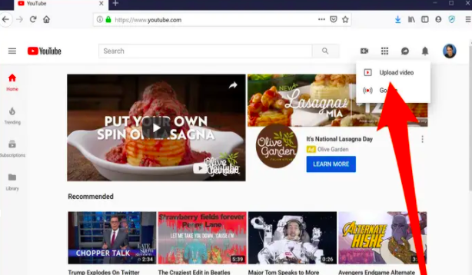

Step Three: Now that you are on the website and logged in, search for the video camera icon on the screen, once you click on that it will bring up a drop down menu. From there click on "Upload Video"
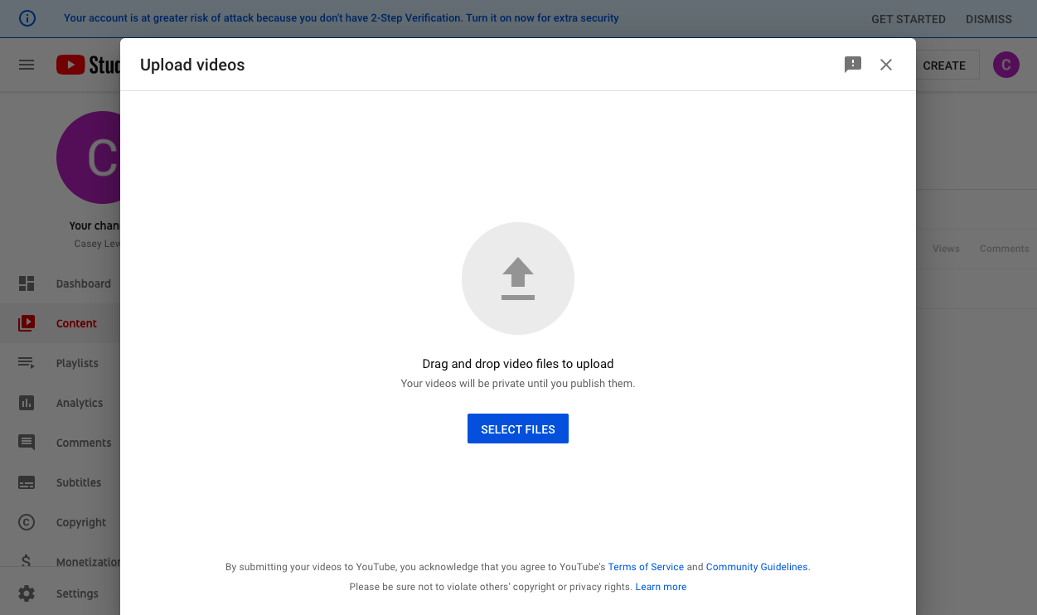
Step Four: The upload video page should appear after step three. You will click "Select Files to Upload". Once you do this you will choose the visibility of the video ie. Public/Private/Unlisted.
Step Five: Once you find the file and video you would like to post it will begin uploading, this will take some time depending on the size of the video. While you wait for it to upload you are able to enter information like the Name and Description of the video.
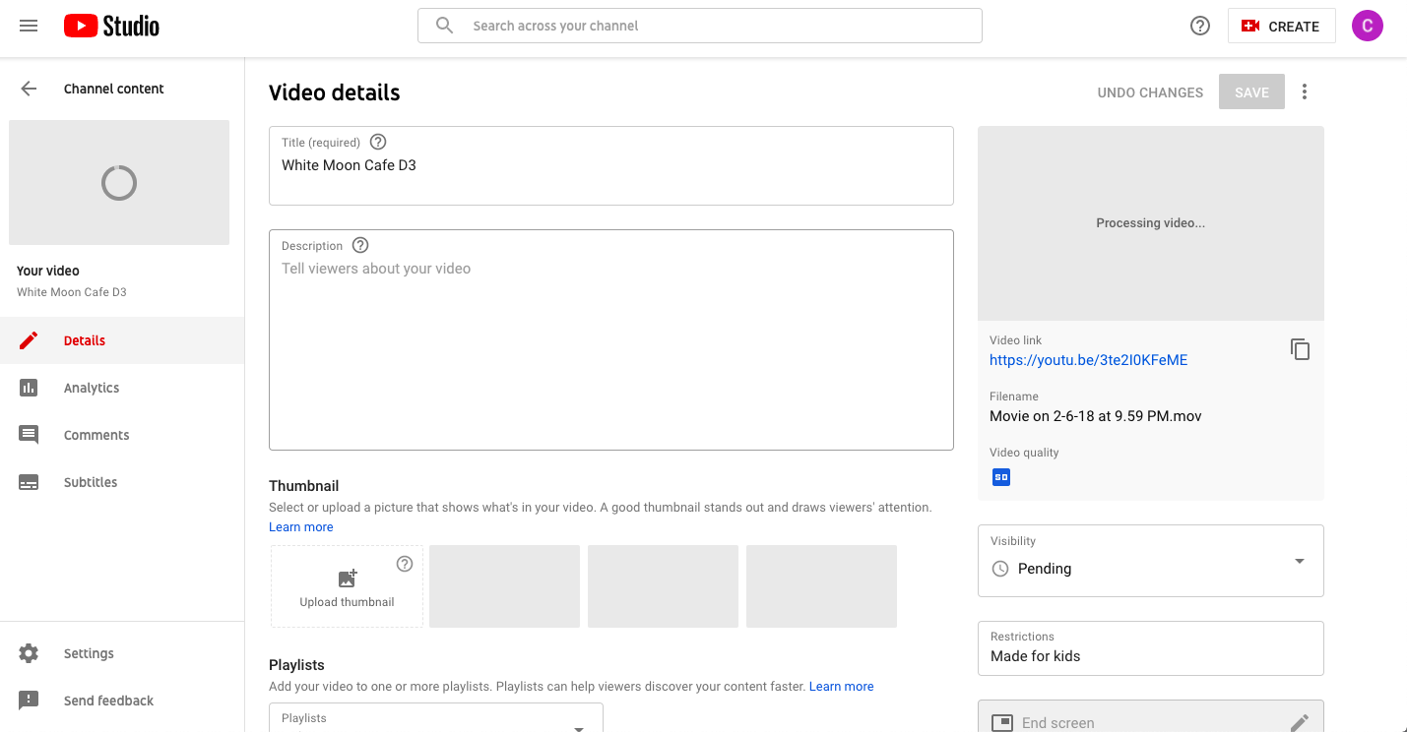
Step Six: Once you have titled the video and entered all the information you are ready to click "Publish" you may do this while it is still uploading or wait until it has finished. Once the video is uploaded it will appear on your page and all of YouTube.

SEARCH ENGINE OPTIMIZATION

What is Search Engine Optimization (SEO)?
It improves and caters to your online website content so that your search engine shows as a top result for industry and consumer-specific keywords. The three main entities involved with SEO are the searcher, the search engine used, and the brand. Brands that attract existing customers and new customers also optimize their websites to appear consistently and effectively in search engine marketing. This comes from understanding keywords relevant and popular to White Moon's respected industry and interests.
Websites are a gateway for White Moon and audiences to connect and establish relationships. A website answers questions and provides information that audiences can use to satisfy wants and needs. With this in mind, optimization includes keywords used in searches, having links to content from credible sources, and having your website linked to other reputable brands. White Moon's website needs to be easy to navigate, simple layouts, and entice the reader to dig deeper or take action to satisfy these customers' needs.

Why does White Moon need SEO?
SEO increases the traffic and actions taken on a website through search engine results. Easily accessible websites with valuable information and user-friendly receive the best results when analyzed by a search engine algorithm. Brands use SEO to drive interactions and sales to achieve return-on-investment goals. Brand awareness is another significant aspect associated with search engine optimization.
Search engines prioritize well-layered, and optimized websites catered toward customers and provide natural popularity for those who follow those guidelines. Increased revenue and brand awareness showcase the ability to satisfy the wants and needs offered by White Moon. Four benefits associated with search engine optimization are:
- Increase traffic: An influx of more customers viewing and interacting with the website
- Cost-effectiveness: Increased site usability: Providing customers with the proper information they are seeking
- Increased site usability: A website that is user-friendly and enticing to the public
- Brand Awareness: The more prominent a website is in search engine results the more likely users will view White Moon's website and share what they have found with family and friends

What is a Quality Score, and How is it Calculated?
A quality score is an element of search engine marketing explicitly used for Google, Bing, and Yahoo! The quality score is calculated to rank ads and the cost per click of those ads. The score is calculated every time a keyword is used to search users and determine and where the ad appears. Factors that influence the quality score are keywords used, the landing page of a website, loading time, mobile usability, click-through rate, and geographic performance.

HELPFUL TERMS
HTML: "HyperText Markup Language" is a standardized system for tagging text files to achieve font, color, graphic, and hyperlink effects on World Wide Web pages.
URL: "Uniform Resource Locator" is the address of a webpage. For example, www.whitemoonnc.com
Search Engine Optimization (SEO): Improving the quality and quantity of website traffic to a website or web page from search engines.
Domain Name: The part of a network address that identifies it as belonging to a particular domain.
CTR (click-through-rate): The number of clicks an ad receives divided by the number of ad impressions.
Landing/Home page: A webpage that visitors see immediately upon clicking an ad.
Quality Score: A score assigned to an ad based on its click-through rate, keyword relevance, and landing page relevance.
Conversion: An action you'd like visitors to take when they are on your landing page. This could be a purchase, a signup, a whitepaper download, etc.
Conversion rate: The number of visitors who took a desired action (converted) divided by the total number of visitors to the page.
SERP: "Search Engine Results Pages." A search engine displays the links of pages in response to a consumer's keyword query. A website can improve its SERP rating to be prioritized in search engines.
Above the Fold: Webpage content that is visible without scrolling. The area above the fold should hold the most critical information.
Below the Fold: Webpage content that is only visible if the reader scrolls down the page. This information should ideally be a lower priority than the content above the fold.
Call to Action: A call to action is an instruction your visitors that is meant to provoke an immediate response. CTAs appear on web pages in the form of button-shaped elements that link to another page or initiate something.
Widget: A webpage is a small application that can be embedded into a webpage. The application has minimal functionality but can add a lot of dimension to your page.

WHITE MOON SEO AUDIT

Domine Name and URL Structure
When potential customers look for coffee shops, they search "coffee near me" or "where to find coffee," "Sylva coffee," "Cullowhee coffee," and "White Moon." Search engines like Google and Bing sort through millions of results to find relevant results. The search engines determine the relevance of a website due to domain name and Uniform Resource Locator (URL). Keep this in mind when choosing a domain name and URL structure to optimize search results in favor of your company. Try to add relevant keywords in the structure of your URL to optimize SERP ranking. The domain name is the label that identifies a website. It acts as the unique address that identifies a webpage on the internet. https://www.whitemoonnc.com/ is White Moon's current URL. The domain name is "whitemoonnc.com."

How Can White Moon Improve?
A quality score can be improved through consistent keyword analysis and always listening to what audiences say within the White Moon industry. Relevant keywords to the business are best for quality score but be careful when grouping keywords. Ad groups are also given a quality score. Ads are best received by audiences when the ads are engaging and descriptive. Remove keywords that have a low click-through rate. This feature of keywords can be found on keyword searches. Google has a descriptive keyword search that provides suggestions for keywords as well.
Landing pages are the first thing audiences see when clicking on your ad. If the landing page takes longer than optimal to load, the more likely audiences are to go back and find another website to answer their questions. Landing pages provide a general overview of the brand and give audiences the first impression. The goal is to have an engaging and thoughtful website so that all questions can be answered and a way to contact White Moon for further questions.

SEO BASICS & BEST PRACTICES

Research & Target Keywords
The first step in search engine optimization is determining what you're optimizing. This means identifying the terms people are searching for that you want your website to rank for in search engines like Bing. There are a few key factors to consider when determining the keywords to target on your site:
- Search Volume: The first factor to consider is how many people (if any) are searching for a given keyword. The more people there are searching for a keyword, the bigger the audience you stand to reach.
- Relevance: Understanding the current market and what products you sell. Research how they stack up in the industry.
- Competition: This means understanding the relative competition (and likelihood to rank) for specific terms.

On-Page Optimization
Once you have your keyword list, the next step is implementing your targeted keywords into your site's content. Each page on your site should be targeting a core term and a "basket" of related terms. Essential basic on-page elements you'll want to understand as you think about how to drive search engine traffic to your website are Title Tags, Meta Descriptions, Body Content, Alt Attributes, URL Structure, & Schema & Markup.

Information Architecture 101
Information architecture refers to how you organize the pages on your website. The way you organize your website and interlink between your pages can impact how various content on your site ranks in response to searches. The reason for this is that search engines primarily perceive links as "votes of confidence" and a means to help understand both what a page is about & its importance. Search engines also look at the actual text you use to link to pages, called anchor text. Anchor text uses descriptive text to link to a page on your site helps Google understand what that page is about.

Execute Content Marketing & Link Building
Google's algorithm is still based mainly on links; having several high-quality links to your site is incredibly important in driving search traffic: you can do all the work you want on-page and technical SEO. There are several ways to get links to your site, but as Google and other search engines become more and more sophisticated, many of them have become extremely risky. Suppose you are new to SEO and are looking to leverage the channel. These riskier and more aggressive means of trying to get links likely aren't a good fit for your business, as you won't know how to navigate the pitfalls and evaluate the risks properly. The following are three core steps for link building: Identify & Understand Your Linking & Sharing Audience, Determining What Content You Can Create & How You Can Promote It, & Map Your Assets to Specific Keywords.

HOW TO OPTIMIZE WHITE MOON'S WEBSITE

Domain Name/ URL Structure

Importance:
  - In order to understand the importance of the company's domain name, one must first understand the difference between a domain name and a URL. The domain name is the general address that is used in order to find your website. For example, the domain name for White Moon is "Whitemoonnc.com." The URL is the unique file that is used to find your website on the internet. For example, the URL for White Moon is "https://www.whitemoonnc.com/."
  - Although it does not seem like a big thing, domain names and URL structures are very important to your website's amount of traffic. In order to have a website that people visit, your domain name needs to be easy to read and inviting. No one wants to click on a link with a bunch of random letters and symbols. Another important tip is to stay broad with your name. Although we have gone over how important keywords are, it is not useful in your domain name. It is vital to keep the domain name short and sweet. Another important thing is to avoid hyphens when making a domain name. For example, if your website was www.white-moon.com it would get fewer clicks than if it had no hyphen. Although these tips seem small, they are essential in driving up the clickability of your website.

Examples of What you Already Have
https://www.whitemoonnc.com/

Critiques
- To broaden this website, we suggest taking off "NC" off the website's end. This will increase the clickability of those outside of North Carolina who may see this website.
- This also decreases the number of characters used, which increases the clickability.

Titles and Title Tags

Importance:
- To first understand the importance of the titles and the title tags, one must first understand what they are. The title itself is the actual HTML element that specifically shows what the title of the page is. The title tags are what appear when googling your website or organization.
- The importance of having a reasonable title/title tag is the same as the importance for everything – clickability. If your Title is too wordy or complicated, no one will want to continue to your website. Title tags are also used to determine whether or not your website shows up based on if it relates to what the consumer is searching for. For title tags, it is recommended to keep your title tag under 60 characters. This is also to help with having your complete title displayed on google correctly.
- When writing a good title tag, there are a few tips and tricks. First, make sure your title tag is not too long or wordy; as mentioned above, it is recommended to keep the title tag under 60 characters. Don't overdo the number of keywords in the title tag. This could actually get you in trouble with Google as well as just annoy your customer. Give every page a title. This allows for different ways for your website to be found by googling as well as increasing the click-through rate. Put the keywords closer to the front of the title tag. This will allow for your website to show up closer to the top when searched. Lastly, make these tags directed at your customers. The top priority is reaching your preferred audience, so write in a way that will make them want to explore further.

Examples of What you Already Have
- <head><title>White Moon | Dark Moon | cafe by day & a wine bar by night in Sylva, NC </title></head>

Critiques
- When searching "White Moon Cafe" in the Google search engine, this is the first thing that comes up, which is good, although the entire title is not shown. The title cuts off at "in" and continues as "..." like mentioned above this is not an ideal way to display a title tag.
- The beginning is good with the title "White Moon | Dark Moon |" this is already 24 characters meaning we have 36 characters left. What we suggest is to add important keywords as well as what you are in the minor characters you have left.
- <head><title>White Moon | Dark Moon |Coffeehouse| speakeasy </title></head>
- This suggestion allows White Moon to advertise what they are and add keywords such as "coffeehouse" and "speakeasy" into the title. The suggestion is also under 60 characters, allowing for the entire thing to be viewed when searching White Moon.

META tag "Description"

Importance:
- The meta tag "description" is important because it improves the clickthrough rate of a website if written correctly. The meta tag is shown below the title tag in google searches. This will give the reader an insight to what they are getting into by clicking on the website. Keywords in the Meta tag description allow for more access to your website. When people search your keywords, the meta tag will cause the website to be shown higher in search results.

- Tips to making a good meta tag description include keeping it below 155 characters. Google usually displays 120-156 characters in a meta tag description. Another tip is to make the voice active and inviting. If the meta tag description feels like someone is talking to the audience, they will feel more drawn in. Including a "call to action" is essential; going off the last tip will draw the customer in. Make sure to include your keywords. Keywords in the meta tag are important to letting google know to show your website when searches with or relating to your keywords are made.

Example of what you already have
  - <meta name= "description" content= "White Moon is a cafe by day & Dark Moon is a wine bar by night in Sylva, NC. We offer brunch, coffee, curated small plates, a wine list, and live music events.">

Critiques
- This is a good meta-tag description. It includes key words such as "brunch", "Coffee", "wine list", "live music". There is also an active voice by using words such as "we".
- The character count is slightly long being 159 characters; therefore, the entire thing will not show up on google when being searched
- <meta name="description" content="White Moon, Cafe by day Wine bar by night. Offering brunch, coffee, wine list, and live music events. Come and visit us!">
- This uses the same key words as well as active language by using the word "us". This shortens the character count to 120 making the entire thing viewable on google.

Heading Tags

Importance:
    - In order to understand the importance of a heading tag one must first understand what a heading tag is. The heading tag for a website is the code that tells the browser how to display your content. Heading tags are used to make the website to navigate as well as clean and nice to look at.
    - A heading tag should be used on the website as an outline to the content. Heading tags start with the most important piece of content and then work their way to the least important. The main heading tag on a page is an H1 tag being the most important. After this comes H2, H3, H4, and so on in a continued numerical order and should decrease in size and importance as they go down the page.
    - Heading tags are important to the website because they can do many things for the company. First off they boost your SEO. A search engine goes through the company's headings to find words that are important to the search being conducted. This means if key words are used in heading tags this will help for your website to show up when your keywords are being searched.
    - Another way that heading tags are important to your website is their ability to increase the readability of your website. The "aesthetics" of a website are everything when trying to catch the attention of your audience. Keeping a clean and easy to read page is important and heading tags are the way to do it.

Example of what you already have:
    - <h1 class="sr-only">Home</h1>
    - <h2 class="h1">VISIT US</h2>

Critiques:
- Although these header tags allow for the website to be easily read and navigated there aren't many up here. When going through the tags of the website the tags above are the only ones found, the rest of the tags used throughout the website are not classified as "header tags". Right now there are only header tags in place for the home page and the section labeled "visit us"
- We suggest that White Moon should create more header tags that will allow for search engines to find Their website through SEO. For example, they can do header tags for subheadings such as "White Moon," "Dark Moon," "Menus," "Private Parties," "events and specials," "About," "Order Online," and "Shop."
- New code:
- <h1 class="sr-only">Home</h1>
- <h2 class="h1">VISIT US</h2>
- <h3 class="h2">White Moon</h3>
- <h4 class="h3">Dark Moon </h4>
- <h5 class="h4">Menus</h5>
- <h6 class="h5">Private Parties</h6>
- <h7 class="h6">Events & Specials</h7>
- <h8 class="h7">About</h8>
- <h9 class="h8">Order Online</h9>
- <h10 class="h9">Shop</10>

- Having these headers for multiple sub headers helps for the searchability for the website. Now when words such as "private parties in sylva" are searched the search engine will recognize that there is a header under the White Moon website with this title and will in turn show this website.

Image Tags

Importance:
- In order to understand the importance of image tags one must first know what an image tag is. Image tags are code used to show the small pieces of image on a website. White moon cafe uses image tags to show the following:



- When writing a good image tag, it is important to describe what the image is and to be specific about what it shows. This is important for SEO because it allows the search engine to know if the image relates to what is being searched. Another suggestion is to keep the alt text fewer than 125 characters, do not start with "image of..." or "picture of…" this is just a waste of characters. Another tip is to use key words but sparingly, only use them if they relate to the image itself.

Examples of What you Already Have:
- <img class="site-logo__expanded" src="https://images.getbento.com/accounts/5060cab13dc5d3f24c5840d439a9777d/media/images/84060WhiteMoon_Logo.png"
- <img class="site-logo__collapsed" src="https://images.getbento.com/accounts/5060cab13dc5d3f24c5840d439a9777d/media/images/33863White_Moon_Logo_Text.png"

Critiques
    - Some good things about these Image tags is that they follow the rules of 1. Don't go over 125 characters within the alt text as well as 2. Do not start the alt text with "image of…" or "picture of…"
    - What we suggest is that you put more words into the alt text that allows for the images to be found better not only on the website but through the search engine.
    - <img class="logo for white moon and dark moon" src="https://images.getbento.com/accounts/5060cab13dc5d3f24c5840d439a9777d/media/images/84060WhiteMoon_Logo.png"This will allow for the image to be easily found when "white moon and dark moon logo"
    - <img class="White Moon Cursive site logo" src="https://images.getbento.com/accounts/5060cab13dc5d3f24c5840d439a9777d/media/images/33863White_Moon_Logo_Text.png" This allows for the image to be easily found when searching things such as "white moon logo" or "white moon cafe logo"

Anchor text an Anchor tags

Importance:
- Anchor text has links embedded in it to lead the viewer to another part on the website with the information they are looking for. For example when clicking "shop" in the top right corner there is a code embedded in that button that looks like:
- <li><a href="/store/" class="btn btn-brand-alt">Shop</a></li>
- This leads the viewer to another page within the website that has the store for White Moon. The anchor text is important to a website because it allows the website to be easily navigated and allows the viewer to find specifically what they are looking for.

Examples of What you Already Have
    - <a href="/hours-and-location/" class="btn btn-brand">Hours & Location</a>

Critiques
    - When clicking on the "hours-and-location" link it leads to a page where you have to click on a page where there are two moons, and you have to pick whichever moon you want the hours to (dark or white moon).
    - The only labels available are "White Moon" and "Dark Moon" this does not explain to the audience what they are getting by clicking on these locations. Therefore, we would suggest putting a label "White Moon Hours and Location" in place of the label white moon and putting the label "Dark Moon Hours and Location" in place of Dark Moon. Each of these labels would have an anchor text that would lead the user to the page with the hours and location of either White Moon or Dark Moon.
    - New code:
    - <a href="/White-moon-Hours-and-location/" class="btn btn-brand">Hours & Location</a>
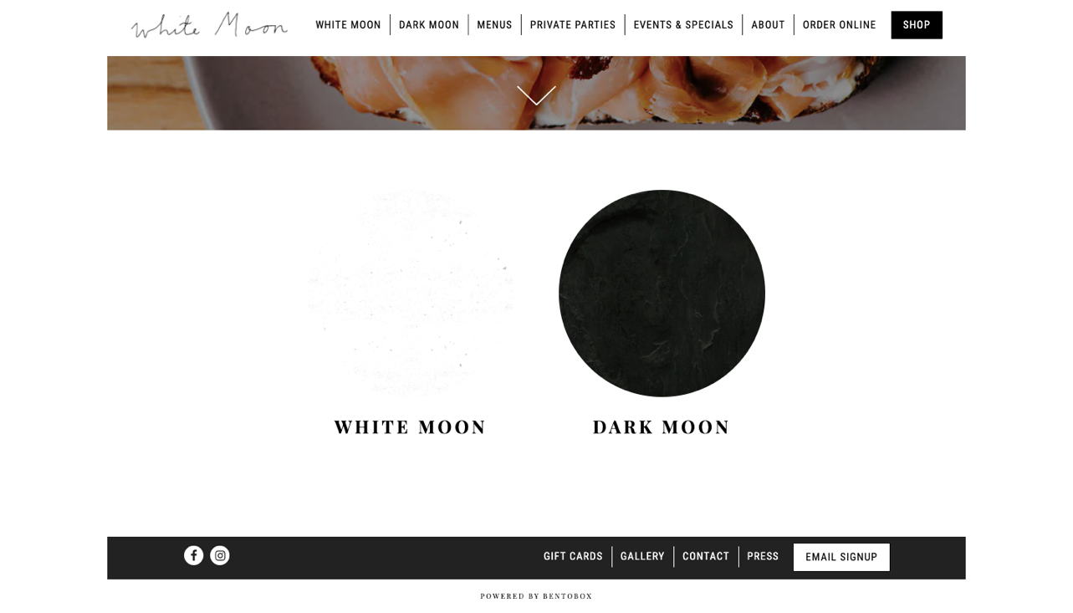
    - <a href="/Dark-moon-hours-and-location/" class="btn btn-brand">Hours & Location</a>

WEBSITE USABILITY ANALYSIS

Organizing and Optimizing Content
The landing page is a start to the main content and can be further clarified throughout the different sections of a website. Currently, White Moon has sections for White Moon, Dark Moon, Menus, Private Parties, Events & Specials, About, Order Online, Gift Cards, Gallery, Contact, Press, and Email Sign-up. These sections are clearly sectioned for quick and efficient access to the exact information audiences want to learn about. The Contact page provides information for audiences to reach out with any questions not answered or not clear.

Include Target Keywords
A lot of keywords on optimized websites can be found in blog posts, articles shared on the website that relate to customers' interests, and text related to the brand. White Moon does not have a lot of text with keywords on the website. We recommend adding keywords through press and articles about White Moon. The website's press section includes two examples of news coverage, but it only contains two links that go to other websites. Include the press coverage text on the page below the current link so that the keywords pop up from the text and allow customers to stay on White Moon's website to read about accomplishments. Too many keywords can become cluttered and decrease the quality score of your website.

Become Mobile-Friendly
Websites that do not have a mobile design for those viewing from tablets or phones risk the audience member leaving after clicking on the link. If using pay-per-click advertising without mobile-friendly usability, the money invested is not producing revenue. Mobile-friendly sites are easy to accommodate. Most services used, including Square Space we recommend, offer accessibility to different forms of mobile viewing.

Secure and Accessible Website
Website security gives peace of mind to audiences that their information is protected while visiting White Moon. Website security is taken into consideration when search engines like Google and Bing put websites through their algorithms. Potential threat notifications are given to those trying to access websites that are deemed as not secure for viewing. Accessible sites are those with easy load time and capable of being accessed with little to no trouble or extra steps included.

Load Speed
Websites with slow load times are more likely to have a higher bounce rate. Bounce rates are the level of clicks to an ad or a website but immediately leave before finding any information. This typically happens when a site is hard to load due to large files and photos or does not have a proper mobile website.

User Experience
The experience of audiences is a broad range of expectations. Simple designs are one of the most important due to the easy navigation to find information. Another key aspect of the user experience is providing a meaningful experience for customers. Meaningful content relates directly to the interests of audiences and relates to their lives.

Links to other Popular Business in the Area
Content that showcases White Moon and content that is relevant and interesting to audiences gives more exposure in ads. Exposure comes from linking information from other credible websites and credible websites linking White Moon information.

Quality
Websites with established reputations have regular content circulating with relevant and popular keywords that work well with search engine algorithms. High-quality photos that are original, consistent with themes, include descriptions both with text and with tagging are most successful. Images that are not tagged will not generate on the search by image section and therefore be irrelevant and a waste of time to the production of the website. Websites that do tag their photos with a few keywords perform better with algorithms. The images promote brand awareness and provide visuals for potential customers to understand what White Moon offers before they ever step in the physical location. It is more important to have good content than to have harmful content and a good web design. Simple designs with modern, well-known content geared toward the wants and needs of audiences are the best option for improving traffic to White Moon's website. Content is provided for blog posts that can be added to add substance to the website optimization further.

Easy to Navigate
Customers do not want to feel confused or overwhelmed when visiting White Moon online. Theoretically, your customers and audiences will not spend a lot of time on your website. Therefore, White Moon needs to provide accessible, fast, and relevant information for the audiences to find. The best way to do that is to have a call to action (CTA). A call to action is a redirection to another page. Providing a call to action will entice audiences to explore the other sections of the webpage further. For example, a prospective customer might look up your hours of operation, land on your page, and be intrigued to look at your menus.
If your website is hard to find information or navigate, they will most likely leave and find information to answer their questions elsewhere. Providing a relevant and understandable call to action gives audiences the freedom to find the information they seek.

Webpage Design
A 2006 study conducted by Nielsen Norman Group used eye-tracking technology to discover a pattern that most users look at on a website. Some elements are more eye appealing than others, like large, bold lettering. In the image below, you can see a pattern which the researchers named the F pattern indicating that the first few words in the text are the most looked at. Customers are looking for keywords and fixed points to guide them through the content of the website page. Customers will not read every word on the website, so it is important to have fixed points and anchors to help them find what they're searching for.

Applying the Information
Quality sites and content are crucial for functional, educational, and beneficial aspects of user experience. The White Moon website showcases several original photos of the menu items and the people involved with the brand, yet the website lacks information or a blog section. Content from curated blog posts is beneficial to White Moon to attract potential customers and audiences. Prioritizing content is a skill that comes from social listening to find what matters most when visiting White Moon's website. Very little content like interviews, articles and various other media are shown for White Moon and Dark Moon.

4 SIMPLE DESIGN ELEMENTS BEHIND A GOOD CALL TO ACTION
It is not uncommon for companies to sink large amounts of money into obtaining traffic to their websites in an attempt to increase conversions. Some of their money might go towards search engine optimization and some might go towards pay per click or search engine marketing. In most cases, the problem isn't traffic generation it's poor "call to action".
- Size: The larger an element is on a page, the more noticeable it will be. Create a call to action that is large concerning other elements on the page but not overdone. Alternatively, if you have more than one call to action, size them in regard to their importance. The primary call to action should be larger than the secondary call to action.
- Shape: The best calls to action are most commonly shaped like buttons as they attract attention and are instantly identified as clickable. Use rounded or circular corners on the ends of your call to action to give it the shape of an ordinary button. Square corners do work as well. However, some users may misinterpret your call to action for an ad or banner and steer clear from it.
- Color: One of the quickest ways to grab a user's attention is by using a bright, contrasting color right within your call to action. Choosing a color that stands out from the rest of the colors used within the page will enforce its significance. Pick a color that is specifically unique to your call to action and is not used anywhere else on the page.
- Position: Positioning your call to action instinctively within the eye path of users is incredibly important. No matter how large, oddly shaped, or brightly colored your call to action is, users will never see it unless it is placed within an intuitive position. The exact position for your call to action will depend on the page layout itself. However, the best practice is to keep the "call to action" above the fold and in a prominent area with plenty of breathing room.

WHITE MOON'S WEBSITE USABILITY AUDIT
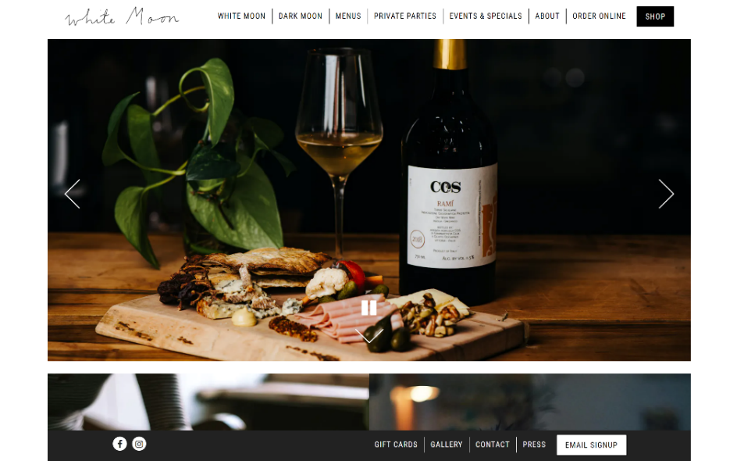
The landing page is crucial for any company. It acts as the face of White Moon to the online world. When customers Google "White Moon," they see White Moons URL. The landing page serves as the introduction to the brand.

Landing Page Necessities

- Introduce the brand. Provide a visual that will attract customers.
- Have a clean interface that is easy to navigate
- Use a simple but effective color scheme that is easy to read
- Provide visible headlines that help customers find what they are looking for.
- The current landing page meets most of these criteria. The landing page has a navigation heading at the top with useful information. The color scheme is simple and easy on the eyes. The vibrant visuals catch customers' attention. The landing page has a gallery that moves automatically. When minimizing the page, the content adjusts to the web browser size. This improves user experience.

Navigation bar
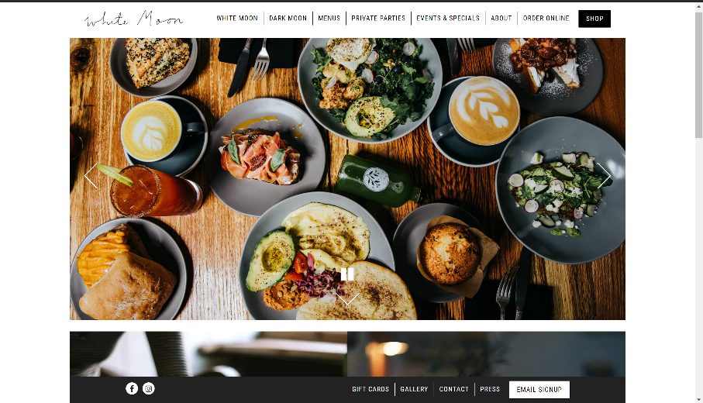
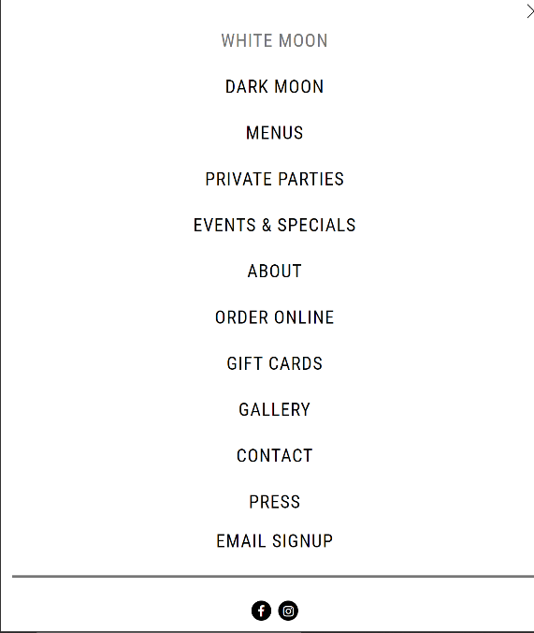

The navigation bar is found at the top of the page while in full-screen mode. If the user doesn't use full-screen, the page adjusts to a pull-down menu that lists the headings. This improves the usability and shows the page is optimized. The same applies to the mobile version. The layout makes it easy to navigate.

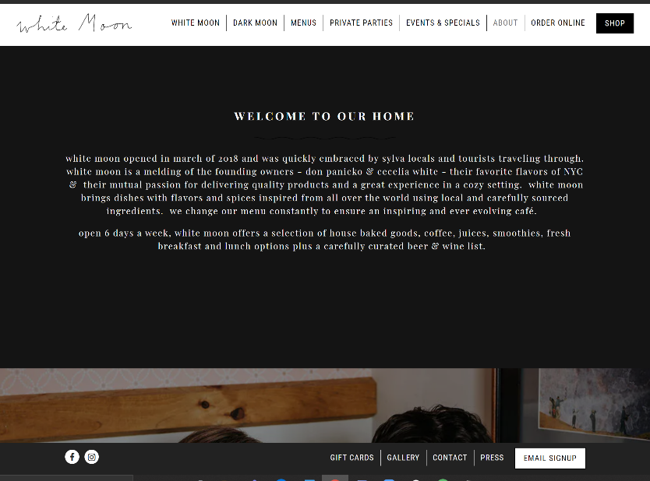
About Us
White Moon's "About Us" Page is short but informative. It gives insight into the owners and story. Customers will appreciate the story because it provides a personal/human vibe. The page includes a picture of the owners and a link to the menu at the bottom. This is a great addition to keep the reader interested. The menu serves as a redirect to an extension of White Moon content.

Menu
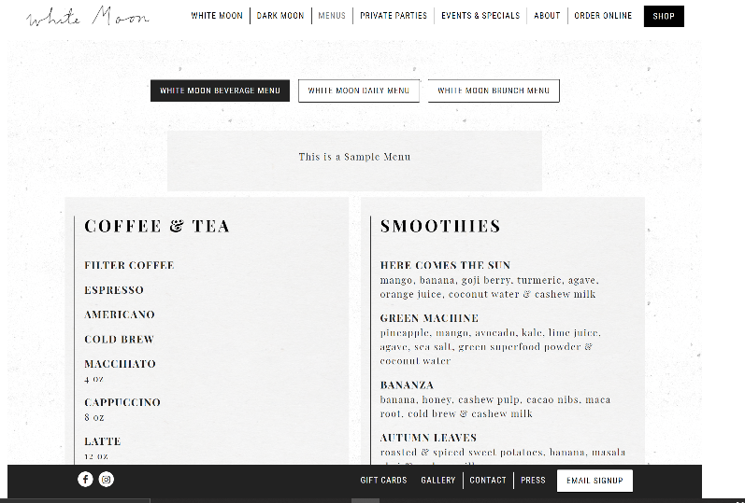

The menu page is one of the most important pages for the café. It's what the customers come to see. The menu is broken into three pages. The first is the beverage menu. It's easy to read and very informative. The only issue is the lack of prices besides the items. The daily & brunch menu includes the prices per item. Customers will appreciate a price chart.

Contact
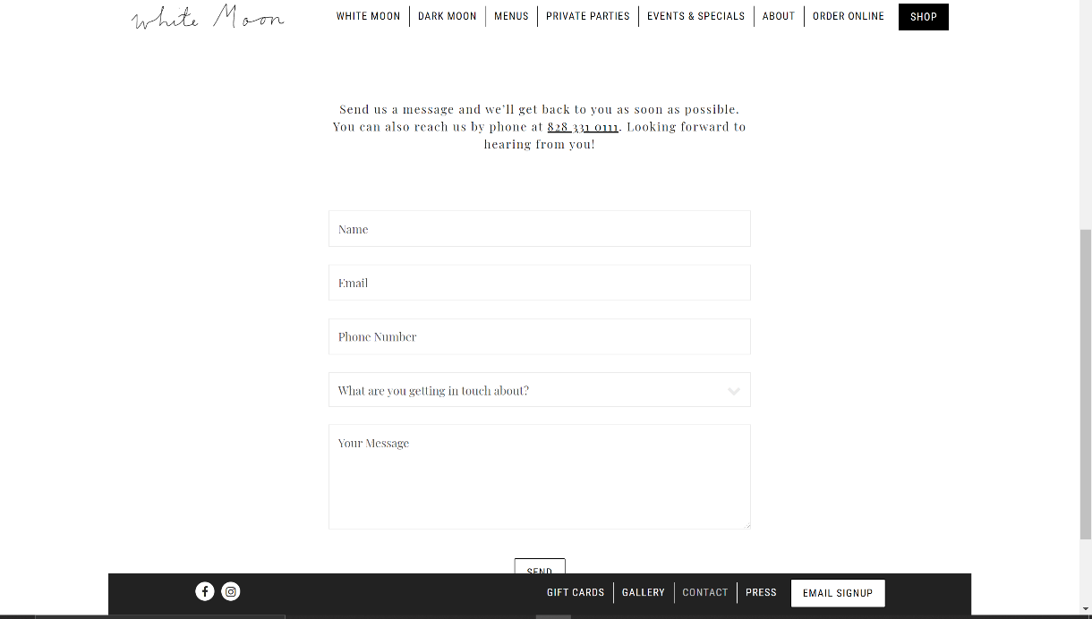

The contact page is a great addition. The page includes a great layout that gives customers a way to reach White Moon. There is also a phone number attached at the top for quick responses. The only issue is the color scheme. There is too much white space that makes it hard to read. It is not easy on the eyes and can distract readers.

Order Online
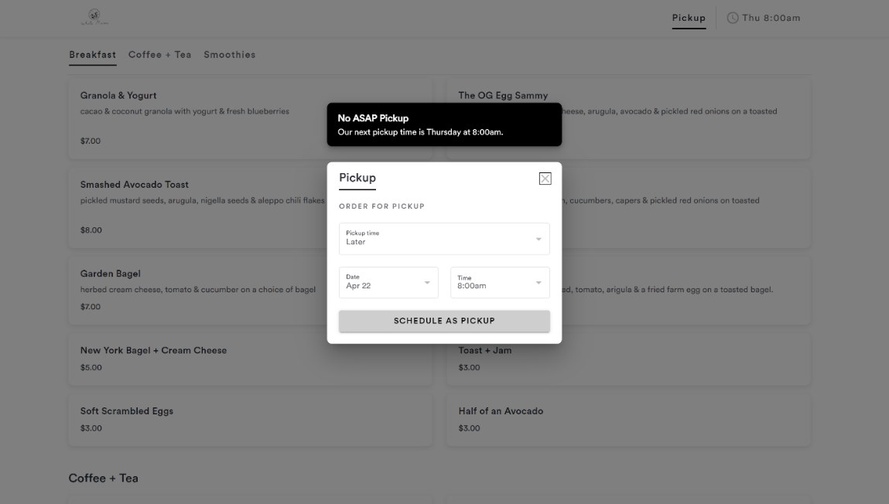

The online order page is beneficial for customers. More so due to Covid regulations. Customers are ordering online now more than ever. Most websites have a redirect link to a third-party website like Grub Hub or Uber Eats. By including a way for customers to order from the website, White Moon is enticing them to order straight from the website. No hassle with third-party apps. The page lists all the prices and makes it easy to find items. The white color scheme can be distracting and hard on the eyes. It is recommended to flip the colors to a black background with white text.

Events & Specials
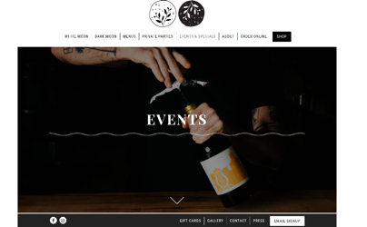
Although there is a section for events & specials, the page is blank. Besides the visual at the top, the page has no content. It doesn't list any information about events or specials. It is recommended to update the page with content or remove it entirely.

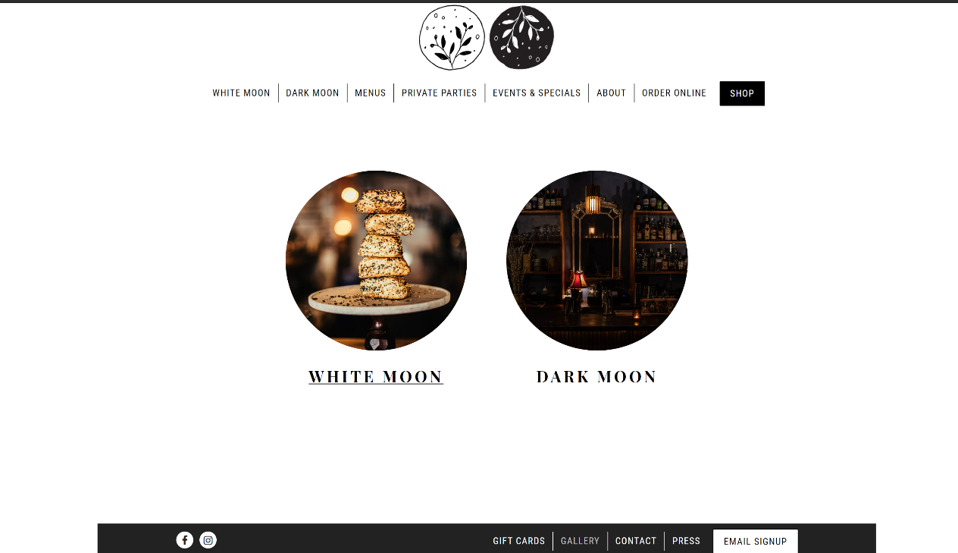
Gallery
The gallery page is a great way to showcase White Moon's atmosphere. When navigating the page, users are met with two options. White Moon & Dark Moon. Both links redirect the user to a colorful gallery that showcases different drinks and dishes. The photos look professional and well-edited.

Email Sign Up

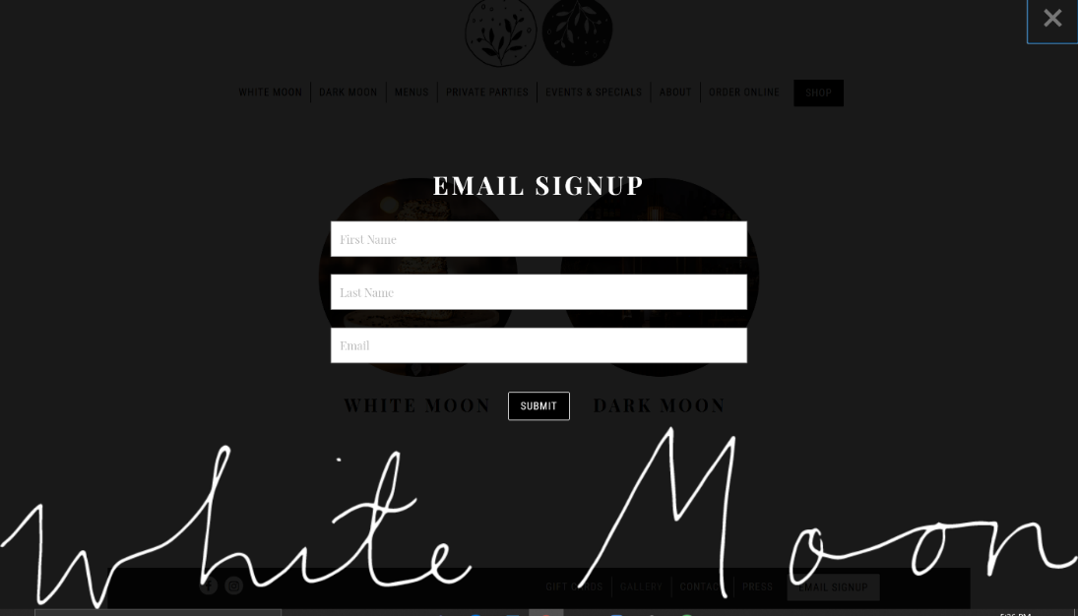

Email signup header is a great way to create an email registry. Customer's opt-in to receive advertisements and notifications about White Moon. You can use the registry to send specials or notify customers of events. Sending a monthly newsletter is recommend reminding customers of new drinks and dishes.

Press
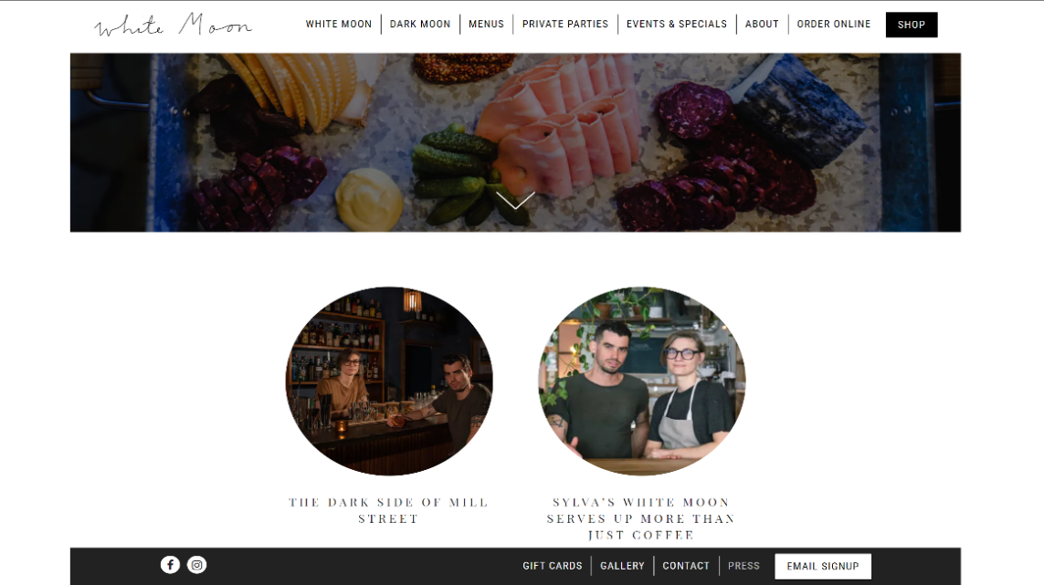

The press page is an excellent addition. It shows off accomplishments and articles about the brand. Consider reaching out to more outlets for reviews. Customers like seeing reviews from creditable sources. They are more likely to come in when they see positive reviews.

Social Media Links
At the bottom of each page, two social media logos redirect readers to White Moon's social media accounts. The logos are a great way to keep readers engaged in the brand. It's recommended adding a Twitter & Yelp icon as well.

Social Media Distribution Plan
We have implemented changes to your website, created a blog, and created content for social media. Best brand awareness practices are to always create content before worrying about where and when to post it. Now that we have provided some usable content to post, we are going to show you how to share content with your audiences. Channels we will use are Instagram, Facebook, and Twitter.

What is Content Distribution?
Content distribution is the act of promoting content to online audiences in multiple media formats through various channels. There are three types of content distribution channels. The first one is owned content distribution and covers all content owned by White Moon. Your website is a great example of media that is owned due to the website being solely for White Moon. Earned content is distributed from third parties and is from press releases, product reviews by companies, influencers, and regular customers. Paid media is explicitly paid for and can be measured by advertisements or promotions that use cost-per-click.

Why is Content Distribution Important for White Moon?
Content distribution provides a way for brands like White Moon to create brand awareness and share information to customers and audiences. White Moon has various goals that will be accomplished by the various types of content that can be distributed and how it is distributed. White Moon’s website is an owned media asset that will be crucial for audiences to find the answer to their questions about the brand. Owned media is a hub for all customers and potential customers to find hours of operation, content, menus, and other aspects of the coffee shop and speakeasy industry.
Earned media for White Moon is prevalent in the product and service reviews. The reviews are on social platforms like Facebook and online locations like Google reviews and TripAdvisor. Reviews show White Moon how to improve services, what customers like, what customers do not like, and even how White Moon can improve. Customers are some of the best assets to give insight on how well the business is doing. Customers provide constructive criticism.
Paid media can be seen through White Moon using search engine marketing or using paid advertising with social media platforms. Paid media is an asset to White Moon through keywords enticing new customers based on their searches and interests on social media.

Benefits of Social Media Platforms
Social networks come in all shapes and sizes. The three platforms we are covering are Facebook, Twitter, and Instagram. They are the most prominent networks. These networks allow for two-way communications with White Moon and customers. It’s crucial to listen to customer feedback. Add more. Businesses use social media to connect with their customers and to gain new customers and audiences. No customer or audience wants to see content that is consistently about the products or services offered by the brand. Instead, customers are more likely to engage with White Moon if you are posting content that they care about. Some examples of content your customer cares about

Competitors Presence
At the end of each section, we will refer to following and evaluate their social media usage. One of the main competitors for White Moon is City Lights Café. City Lights Café is located in downtown Sylva right around the corner. This Café has a vastly large menu with a variety of items. At City Lights Café they offer a variety of food and drinks, both alcoholic and non-alcoholic. The food items on the menu range from breakfast items to dinner. For almost every food item, there is a vegan, gluten-free, and dairy-free alternative. The beverages range from coffee, soda, and wine. City Lights Café is not only pet friendly, but they also offer a kid’s menu for children under the age of 12.
Another big competitor of White Moon Café is Dunkin’. Although Dunkin’ is a chain restaurant it is still one of White Moon’s biggest competitors because of where it is located in Sylva. Dunkin’ has its very own app as well as a reward system for its members known as “DD Perks”. Dunkin’ has menu items including both food and drink options. They offer coffee, refreshers, smoothies, as well as breakfast food items.

Facebook

Almost everyone you talk to now days has a social media account. Facebook is the leader by far, with the number of users that they have with more than 1.23 billion. Facebook is a great way to market your business to people of all ages. It is easy to use and just be used as a free account for your business if you so choose. Facebook has many more capabilities though.
Facebook is a social platform that allows people to make free profiles for themselves, their business, or other types of organizations, for example charities, and other groups to promote common interest like sports, tv shows, or other activities. Facebook allows its users to post videos, pictures, articles of interest, or just general status updates. For business purposes, Facebook is a great way to advertise your business and have your loyal customers keep track of what is going on with your business.

Your Facebook Audience
On White Moons Facebook's account there are 1,214 people who like their page. Although there are quite a few followers for white moon Facebook account the interaction is low. The likes on each post tend to vary from 20-60 likes. There are even some with as little as less than 10 likes.

Best Practices

Prioritize Aesthetics
The first items that should be prioritized are the profile picture and the cover picture. Use a picture of the logo as the profile picture so that the company's page can be easily identified. The cover photo should be eye catching to the audience to intrigue them into looking at the rest of your content.

Engage with Customers
An excellent advantage of using Facebook in the marketing for White Moon Coffee Shop is that you are easily able to engage with your customers. You can post information to your audience with news surrounding White Moon Coffee Shop. Getting the audience involved by asking them questions on preferences and reviews of the business.
Advertising through Facebook allows you to set criteria options for you to target specific people that would actually be interested in your business instead of just blindly advertising to the masses.

Take Advantage of your Resources
Facebook is heavily involved in the social listening strategy. Facebook allows you to search up other coffee shops and see what their customers are saying about their likes and dislikes of certain businesses. You can incorporate those things that customers like about certain coffee shops in the area to attract more customers to White Moon Coffee Shop. Looking through your own page and others can help you identify key words that will help you target specific groups of customers as talked about in the social listening strategy. Facebook relates to the social listening strategy because it offers you a way to find more key words as time goes on. You can see post from customers about what they liked and disliked, as well as respond to both positive and negative reviews posted to your own business.

Find Your Target Audience
When trying to reach the target market that White Moon Coffee Shop Facebook offers a unique opportunity to put ads out that hit your specific target market. The criteria in Facebook allows you to post ads targeting people in certain location, by age, genders, or even languages. White Moon Coffee can zone in their target as narrow as wanted or leave it as broad they wish to hit just general people.

Example
White Moon Café has a very engaged Facebook, and they post everything a customer would want to see. For example, customer reviews and images of products they offer. White Moon is very active on Facebook with interacting with guests and letting their guests know they are appreciated. White Moon has their hours, locations, and information regarding events also posted to their Facebook profile.
City Lights only uses Facebook to announce updated information about the Café, innovations they are getting into, and uses photos to promote items. City Lights utilizes Facebook to give their customers an opportunity to submit an online directly over of their profile. On their Facebook page, they also included their hours, locations, reviews, and ratings from customers, and links their contact information. City Lights also included they offer outdoor seating with free wi-fi.
Dunkin’ Donuts has a Facebook account, but it is not related to just one location because they are a chain organization. Because of this, a lot of their post are for the stores nationwide rather than local deals. Dunkin’ Donuts uses Facebook to promote its products and provide information on products instead of using it as a way to interact with its customers.
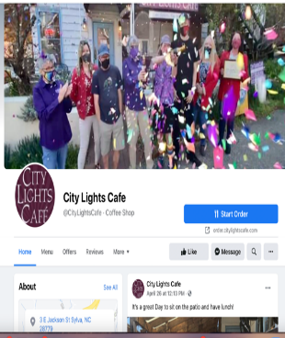
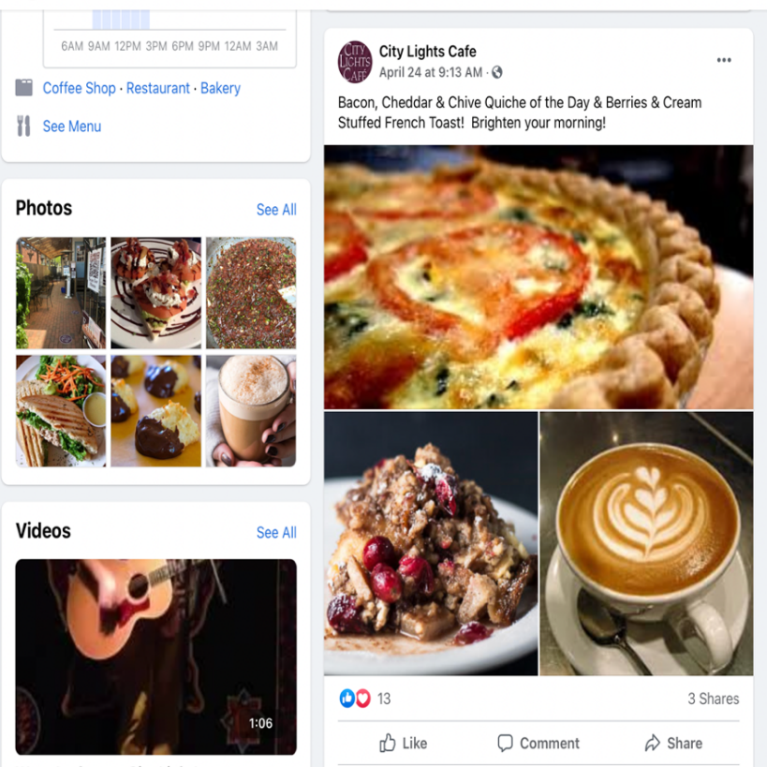
CITY LIGHTS CAFÉ

DUNKIN’:

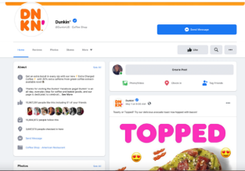
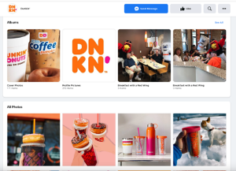

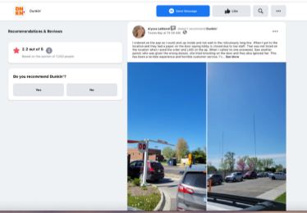

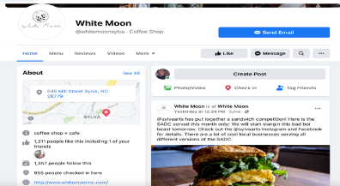
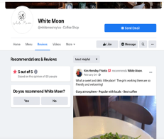
WHITE MOON:

Twitter
Twitter is labeled as a microblogging system with short posts up to 140 characters. Users tend to follow people they know and companies that make interesting content. Twitter posts can be shared on to timelines by getting retweeted and liked. Twitter is an amazing way to stay relevant and interact with customers.
Twitter has an advertising audience of 353 million people and is predicted to grow about 2.4% within the year 2021. It is statistically shown that 90% of the US population is familiar with twitter even if they do not have an account. Twitter is the 6th ranked app globally.

Your Twitter Audience
- Go to twitter.com
- Sign up with a username and a password
- Add a profile picture, a header, and a bio
- Start following people who may tweet about similar interests and try to get followers by advertising your new Facebook
- Start tweeting!

Tweets about White Moon:

Although there are some tweets about white moon as shown above there aren't many and these tweets are from 2018 and 2019. Because social media is always moving it is important that your twitter account is constantly pumping out content in order to stay relevant. Even a simple “good morning followers of white moon make sure you stop by and get you a cup of coffee to get through the day today!” is better than no tweet. In order to keep people involved and talking about your company you need to continue to stay relevant.
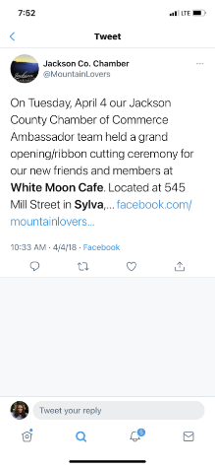
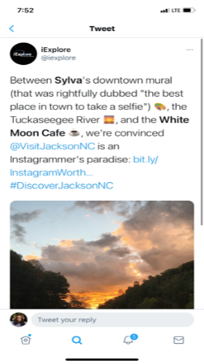

Best Practices

Make your tweets short and to the point
Twitter is a face- paced environment. Part of the appeal of twitter is the short spurts of information given all in one place. Don't overload the tweet with lots of words, just make it short and sweet and to the point. Occasionally it is okay to share more information through the creation of a thread or by linking a website with more information within the tweet, just avoid doing this all of the time

Use Visuals
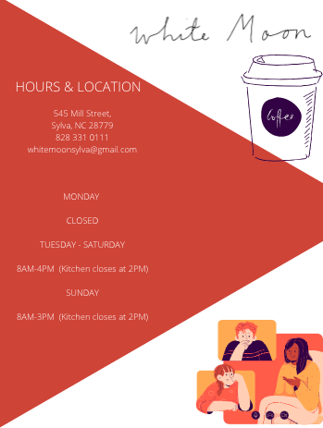
They say a picture is worth one thousand words and they're correct. Visuals such as pictures, gifts, and videos allow for you as a company to put a lot of information in an easier to digest way for the audience.

Engage the Audience
Twitter has tools such as polls that will help your business to engage with your audience better. Sending out a poll will not only give you instant feedback from your audience, but it will also show your audience that you care about their opinion. Twitter is also a good way to engage with your audience by liking, retweeting, and replying to customer tweets about White moon. This will also show your audience that you appreciate and care about their opinion of your establishment as well as showing others that you as a company are affecting people enough for them to tweet about.

Keep Hashtags to a Minimum
Although it is tempting to use hashtags in order to spread information, too many hashtags are tacky. It is important to only use one or two hashtags within a tweet. This goes along with keeping your tweets short and sweet, you only have a handful of characters to use, don't waste them on hashtags. Also keep your hashtags relevant to what you are saying. Don't just use hashtags because they are relevant.

Example
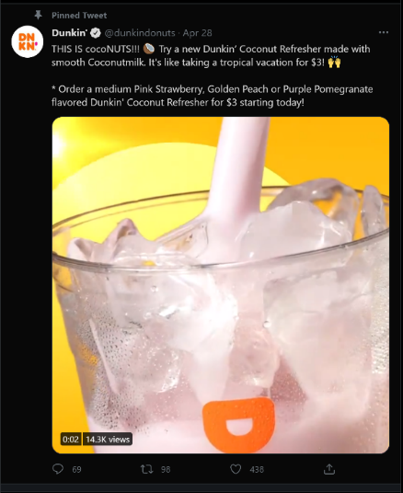
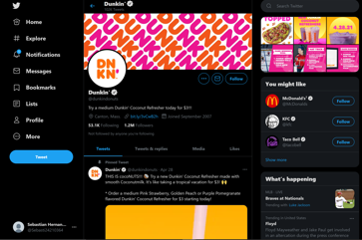
Here competitor Dunkin is showcasing its new Coconut milk. Pay attention how they crafted the post. They used emojis, Bold, Caps, and vibrant colors on the visual. They also included the price tag.

Instagram
Instagram is a social media app that is focused on sharing images and videos. Instagram is a great tool to use when sharing behind the scenes of your company. Instagram is good to stay relevant by posting on the feed as well as utilizing stories.
It is estimated that Instagram has 1.074 billion users. 71% of Instagram's users worldwide are under the age of 35. The average daily time spent on Instagram is 53 minutes. It is estimated that 71% of businesses use Instagram

Your Instagram audience
White moon currently has 2,877 followers. The most recent posts have a variation of 100-200 likes on each post. There is also a lot of interaction with their audience through comments. White moon is very good with liking and replying to comments from customers.

Best practices

Post High-Quality Images
Instagram is only visuals, so it is important to make sure that those visuals look good. People tend to gravitate toward pages that they find aesthetically appealing. Make a theme and stick to it. Maybe your theme could be a slight orange tint to each of your pictures. Whatever you choose, stick to it. It allows for your page to get easily digested by the audience.

Keep the Content Going
Instagram, like most social media platforms, is always changing. There are trends coming and going constantly. In order to stay on top of the constantly moving aspect of social media constantly producing content is key. Your goal should be to stay relevant, have the audience constantly see your post and get reminded of who you are.

Optimize stories
Stories are important for keeping up to date in the audience's eyes. The goal for Instagram stories is to stay at the front of peoples feed when they go on Instagram. This is done by constantly pushing out content. Stories are also important when interacting with customers. Instagram has tools such as polls and places to ask questions to the audience. This is helpful for automatic input from customers as well as making the audience feel heard.

Post at Optimal Times
There are specific times when Instagram is more interactive than other times. Instagram has the most traffic Monday-Friday 9am-4pm. Although that being said it is best to look at your personal engagement because you may be able to find a narrower time that is best to post.

Example
White Moon Café uses Instagram as a way to share images of food or beverages and has a biography including their hours. White Moon café is very active on Instagram when it comes to posting stories that last up to 24 hours. They post things customer experiences, photos of menu items made that day, and images of the coffee itself.
City Lights actively uses Instagram to interact with their customers, and as a way to share photos of popular menu items.
Dunkin’ has a very active Instagram account where they tend to post products and promotions going on nationwide. Recently, Dunkin’ used Instagram to host a giveaway for their customers. In order to have a shot at winning this giveaway, customers had to follow two simple steps; follow Dunkin’ on Instagram, and post photos showing how Dunkin’ is a part of your love story before the expiration date. The last thing Dunkin’ uses Instagram for is to post 24-hour stories that are images of possible drinks and to promote their happy hour deals on the corresponding days.

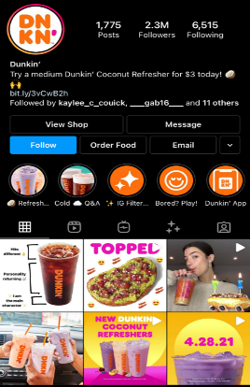
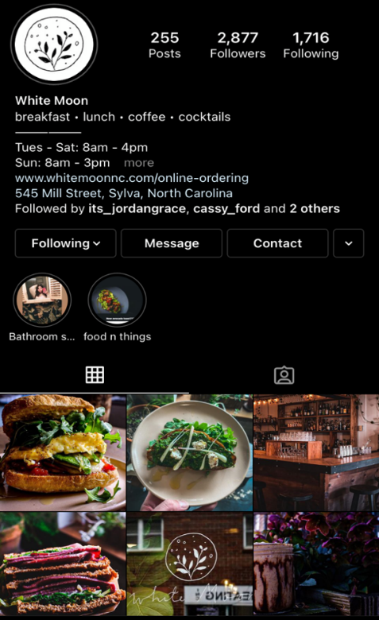

How to Distribute Your Content

Facebook

Creating a Facebook account
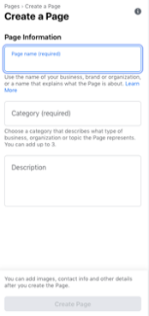
Step One: Your business name and description
First you want to name the page White Moon/Dark Moon or any another name that people may search for to find your business. Then use the category section to tell people what your business does.

Step Two: A profile photo and cover photo
Next you want to use some of the pictures we suggest that best represent your business. However, many businesses choose to use their logo as a profile photo. For the cover photo, choose an image of your store, products, or one from a current marketing campaign.

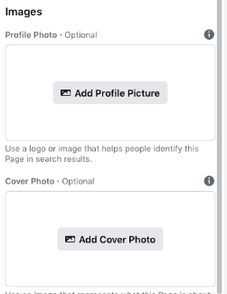
Step Three: The action you want people to take
Lastly at the top of your Page you can add a call-to-action that directs your Page visitors to do something, like visit your website or call your store. It just takes a few clicks.

“Get Spooky with White Moon” Content from Content Strategy for White Moon
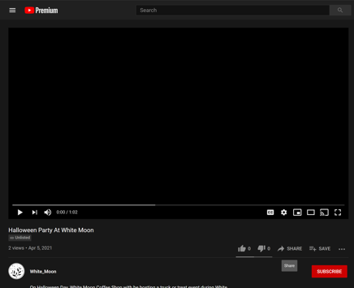
In the content strategy we made a Halloween party video. This could be posted on Facebook extremely easily.
Step One: Open the video via link.

Step Two: Click the Share icon below the video.
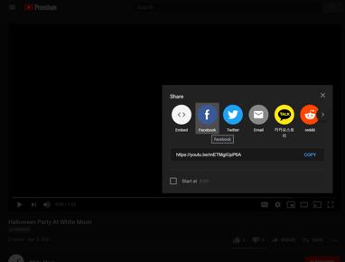

Step Three: Add a caption and description then post the content
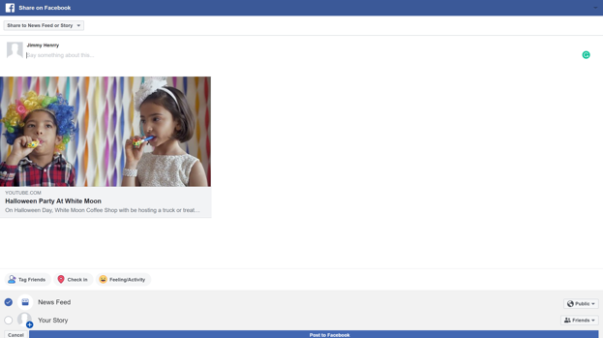
Make sure the content is set to Public and change the accessibility to everyone. You want as many people as possible to see the content. Make sure to go back and monitor the post. Customers may ask questions.

Twitter

Creating a Twitter Account
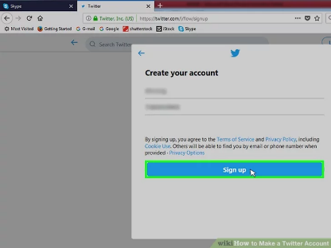
Step One: Once ensuring you have downloaded the app or entered the address into the web browser you will be faced with a sign in and Create an Account option.

Step Two: You will need to choose a username and password again and you may be required to enter a verification code.

Step Three: Now that you have your new account you will want to start to follow people, from people you know to famous people yo280u look up to. Many businesses also will have accounts you should look into following to try and create a connection.
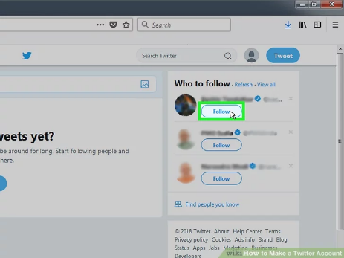

Step Four: Select the new tweet or the blue button that looks like a quill. From there a text box will appear when you can begin typing your tweet, tweets are limited to 280 characters. You can also post photos to twitter whether it be just image or the image along with a tweet. Select the camera icon to take or choose a image to post.

Instagram

Creating an Instagram
Once you have downloaded the app onto your or entered the URL into your browser you will be given the option to sign in or create an Account.
Step One: Making an account
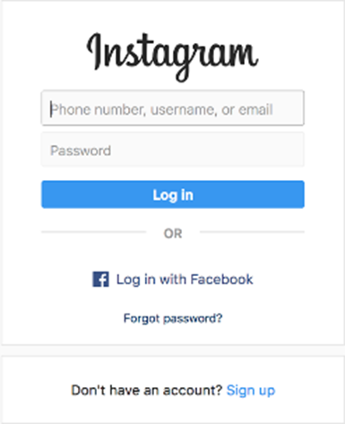
For first time users you will proceed to sign up where you will create your account. You will then choose a username and password of your choice for your account.

Step Two: Adding info
You can then incorporate your own personal profile picture, and account description for your business or personal Instagram. You may click the Edit “gear” in the top corner of the app of screen to edit your profile itself at any time.
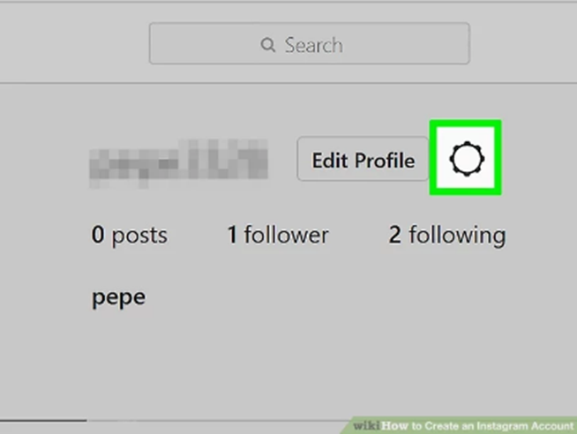

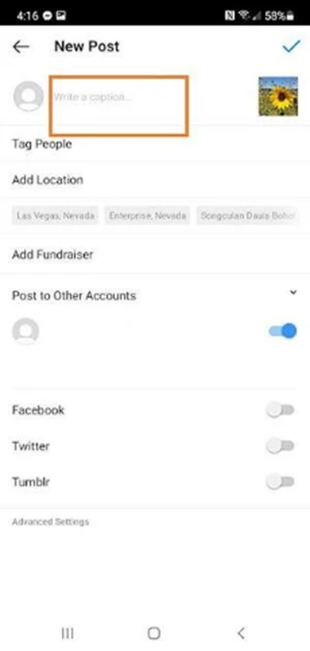
Step Three: Posting on your Instagram feed
Tap the + icon at the top of your screen. This will be your starting point where you can take a photo in real time or choose a previous photo from your camera roll. You can then crop the image, add a filter, add more photos to the post, and edit your photo. Be sure to create a caption and add relevant hashtags to ensure you reach the largest audience. From this final page you can also elect to share this post to other social media platforms like Facebook and Twitter via Instagram.


HOW TO POST STORIES ON INSTAGRAM
Step One: After making sure you have an account and are logged into the proper account you will begin by tapping the Camera Icon in the top left.

Step Two: Once the camera is open you may record a video or take a picture like you normally would. After that you can choose to add a range of filters or text to the image or video.
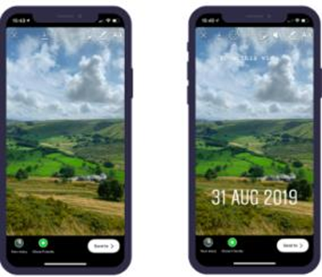
Step Three: If you have already taken the video or picture you can tap on the bottom left corner of the screen once you have got the add a story screen. By tapping the images in the bottom left corner, you will bring up your previous photos and videos, from there you may select one to add to your story.

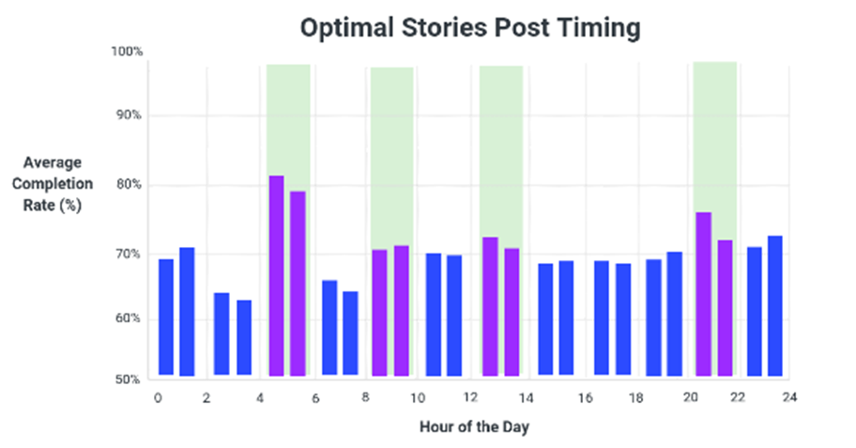
Pro tip: For a business it is good to know that stories only last 24 hours and you should schedule your postings to go out at the most optimal times. One to Seven stories a day is a tried-and-true amount to retain the audience without an overload of information.
Step Four: Tap “Send To” in the bottom left corner and select “My Story” and tap post. Your story is now posted for your followers and others to see.

INSTAGRAM POLLS

Now that you are capable of posting on your story it is imperative you know how to post Polls onto your story as well. It is called a Poll “Sticker”. What this does is provides you the ability to ask your followers questions and see results from your friends and followers.

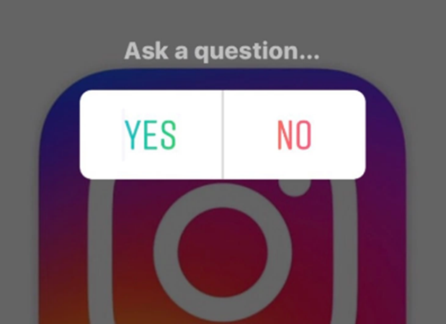

Social Media Objectives
Objectives need to be created in order to measure success and monitor progress. Start by developing a specific target strategy for your business. Social media is all about trail & error. A great company takes risks and evaluates them after. Try meeting together and planning out short term & long-term goals. Working towards goals will give you a higher chance of achieving them.

Facebook
Facebook serves as a main hub for White Moon. You can look at it like a blog. It’s a mini website that’s meant to incorporate social interaction. On average White Moons post get 20-60 likes. With 3-5 comments. The overall look of the page is appealing and informative.
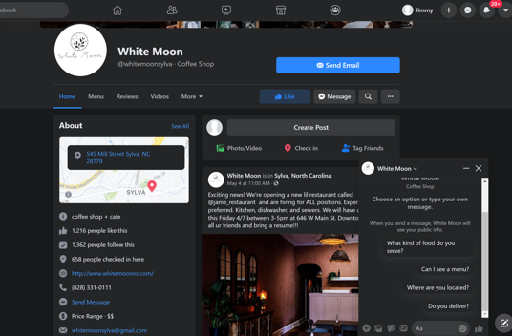

Short Term Objectives
A great way to increase interaction would be to start a publishing schedule. Have content ready to post and be constant with it. Customers need content in order to interact with it. In theory the more content the more interaction. The catch is that you must post quality content. Look at the publication schedule created in the Content Strategy for inspiration.

Long Term Objectives
If Facebook following grows substantially or doesn’t at all, its worth considering a giveaway. The giveaway is great for many reasons. It gives the business free exposure via shares & interactions. The best way to go about it is to offer a prize. You can do coffee for a week or a $50 gift card. Have the requirements be simple. Follow the account, share the post, and post a comment. Facebooks algorithm will pick up on this. It will be more likely to be shared to friends of the person reposting the photo.

Twitter
Currently White Moon has no twitter presence. After setting up the business account White Moon should try to establish & get a feel for the platform. Check out with the competition is doing and establishing a plan for distribution.

Short Term Objectives
Start by getting a feel for how Twitter works. It is mostly text based but there are options for graphics & stories. They have also implemented a live video feature like Instagram. The main objective is to respond and post on a regular basis. Customers like fast responses. They will use the @ feature to ping White Moons Twitter account. Make sure to have notifications turned on. You don’t necessarily have to have unique content on there. It is acceptable to double dip content. For example, use the drink video posted on Instagram to showcase. It is also crucial to learn about the hashtag system. This is the main way the Twitter algorithm operates and sorts through the information posted.

Long Term Objectives
Once you have a feel for the platform consider planning out a campaign. What is means is establishing a hashtag that people will share. Make sure it relates to your brand. For example,45 try #WMdrinkrequest. Post a short Tweet asking customers to submit drink ideas. Brand it as a customer feedback program. Users will use the hashtag. The tag has the potential to go viral and reach customers from all around. You are growing the brand by having others share on your behalf. Measure success by the number of hashtags you see.

Instagram
Instagram is White Moons most popular platform. It’s a great platform to showcase drinks & overall aesthetic of White Moon. Currently White Moon uses it to post its hours, link its website, and showcase its meals. On average, posts get 150-300 likes. That’s a great start for a local coffee shop.
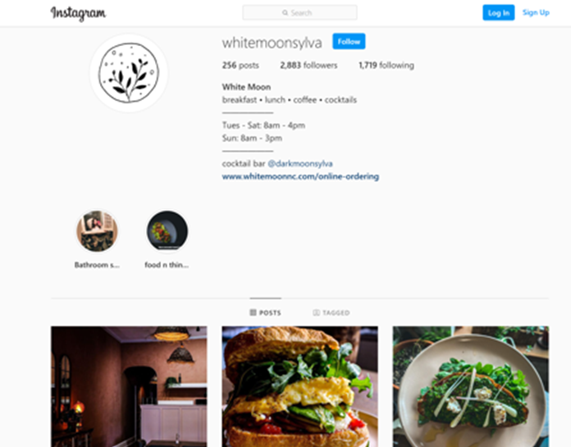

Short Term Objectives
White Moon should try to post stories on the regular. These stories help give customers the executive scoop on what’s currently going on. It can be as simple as an employee making a drink or a busy lobby. Customers will see this and think about the brand. If they see a busy atmosphere in real time, they are more likely to check out the establishment. Use stories to make updates as well. Share important information like hours, specials, and giveaways.

Long Term Objectives
White Moon should strive to get their follower counts up on Instagram. That’s the main way the Instagram algorithm works. It’s based of interactions and followers. White Moon can gain important insight by posting polls. These are advanced ways of customer interaction. Most companies have something simple like “did you like this drink”? The poll will have a yes or no option. Take it to the next step by recording responses. Showcase different drinks and slowly see what customers prefer. If there is a large demand for a spice latte during the summer, consider bringing it back.

Social Listening Strategy Appendix

Extra Keywords

LOCAL BARS
Keyword | Competition | Avg. Monthly Searches
Bars near me | Low | 1M-10M
Downtown bars | Low | 10K-100K
Speakeasy near me | Low | 1K-10K
Night life | Low | 10K-100K
Bars | Low | 1M-10M

BEVERAGES
Keyword | Competition | Avg. Monthly Searches
Cold brew near me | Low | 1K-10K
Green tea near me | High | 1K-10K
Matcha near me | Medium | 1K-10K
Smoothies near me | Low | 100K-1M
French press | High | 100K-1M
Espresso | High | 100K-1M
Sour wine | Low | 100-1K
Cocktails | Low | 100K-1M
Cocktails near me | Low | 10K-100K
Refreshing drinks near me | Low | 100-1K
Downtown coffee | Low | 100-1K
Juices near me | Low | 10K-100K
Fresh juice near me | Low | 1K-10K
Daytime cocktails | Low | 100-1K
Mimosa near me | Low | 10K-100K
Bloody Mary near me | Low | 10K-100K
Lemonade near me | Low | 1K-10K

FOOD
Keyword | Competition | Avg. Monthly Searches
Brunch near me | Low | 100K-1M
Fresh yogurt near me | High | 10-100
Breakfast sandwiches | Low | 10K-100K
Smoked salmon near me | High | 1K-10K
Organic salads near me | Low | 100-1K
Bagels near me | Low | 100K-1M
Gluten free bread near me | High | 1K-10K
Lunch sandwiches near me | Low | 100-1K

DOWNTOWN LIFE
Keyword | Competition | Avg. Monthly Searches
Outside seating | High | 1K-10K
Downtown shops | Low | 100-1K
Outdoor seating area | High | 1K-10K
Outdoors dining | Medium | 100K-1M
Outdoors seating | High | 10K-100K

GEOGRAPHIC
Keyword | Competition | Avg. Monthly Searches
Map of western north Carolina towns | Medium | 10-100
Towns near Asheville nc | Low | 1K-10K
Map of western nc towns | Medium | 10-100
Sylva nc | Low | 10K-100K
Western Carolina University | Low | 10K-100K

Content Schedule Appendix

How to create custom visuals Using Canva
There are many websites to make custom visuals. One we recommend using is Canva. It's a great tool to make and edit images. You can produce flyers, posters, colorful text, edited pictures, and other great content.

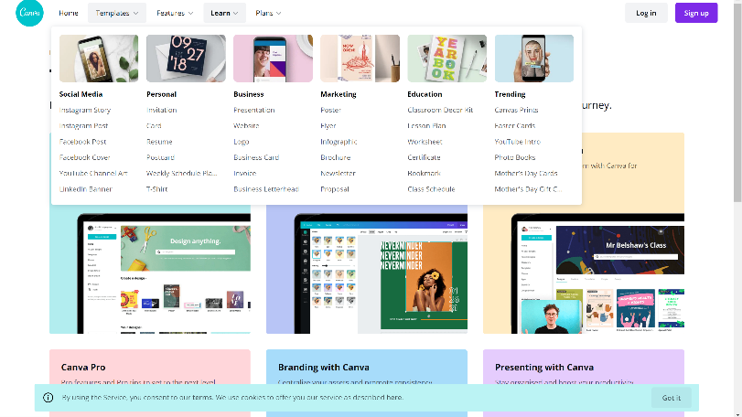
- Login into Canva
- Get inspired and write down concepts/Goals
- Apply them and pick a content type
- Insert photos or use template
- Get creative and unique. Use a color pallet that will attract customers
- Publish and polish the content
- Print or save the finished product

How to RECEIVE WRITTEN CONSENT FOR PHOTOS

A written consent for photos and videos should contain the following information:
- The business name
- A short description of the intentions of the photos and videos along with what the consent entails
- A sentence about how the consent form provides the rights to the visuals to the business
- The full name of the person included in the photo or video
- A telephone number for the person
- An email for the person
- Their signature and the date

Website Optimization Appendix

Common Technical SEO Issues
Some common mistakes and issues that most sites face that even smaller to mid-sized businesses can benefit from being aware of Page Speed, Mobile Friendliness, Header Response, Redirects, Duplicate Content, XML Sitemap, &Robots.txt, Meta NoIndex, & Meta NoFollow.

How to Track & Measure SEO Results
So, you might be asking, how do you track whether and how well it's working? Think about the following key metrics to focus on, but with each metric, there are some key factors to consider as you measure your site's SEO performance. Monitor your site's Keyword Rankings, Organic Traffic, Organic Leads & Sales.

Additional SEO Considerations (Such as Mobile, International & Local SEO Best Practices)
For many businesses, getting the technical aspects of SEO right, understanding the keywords you want to target, and having a strategy for reaching your site's pages linked to and shared is all you need to know about SEO. A few types of search environments that require unique approaches include:
- International SEO: There are several benefits and trade-offs to different approaches to ranking sites in other countries and different languages.
- Local SEO: For small businesses and franchisees, getting local rankings for different variations is the most valuable organic search traffic available.
- App Store Search Engines: If you have an app, either as the core product offering for your company or as a means for enabling mobile users to interact with your business. Having your app show up in searches on various app stores can be extremely valuable.

SEVEN TIPS TO STAY AHEAD OF THE COMPETITION
• Higher ad quality saves you money: the higher your ad's quality score, the less you have to bid to win the auction.
• Granular is better than general: Targeting - > Ad Creative - > Landing Page. The more tightly the three are connected, the better. A well-designed ad group yields more traffic at lowers costs, which may result in more conversions.
• Lower conversion threshold is better: If your conversion threshold is high, Google will have no way of knowing that some micro-converted people are also your target prospects. Google sees higher conversion rates for your ad; it'll assign it a higher quality score. This way, you'll get double value from setting your conversion threshold at a minimum mark.
• Is search network too costly? Go for Display instead: As a rule, Search network traffic is more targeted than Display network traffic and boasts higher conversion rates. But first-page bids for specific search phrases may be sky-high:
• One should separate Display & Search ads> Search network ads are targeted using keywords. Display network ads have more targeting options, keyword-based targeting nevertheless being the most precise. If you target both networks within one campaign, it gets more rigid and harder to adjust to both networks at once. Search network targeting should be tight and focused on achieving higher click-through rates and quality score.
• Watch out for mobile traffic: Mobile traffic may not suit your business model and may be capable of bringing you thousands, millions of poorly targeted visitors. As I mentioned earlier, you can't fully stop getting mobile traffic, but you can take steps to reduce it.
• You CAN crack anonymous.google: In AdWords, the traffic from such placements is shown in bulk under "anonymous.google". And at first sight there is no way to distinguish the underperforming "anonymous" placements that drain your money, nor exclude them from the targeting. There is a workaround that can be implemented.

Content Distribution Appendix

How to Set Up a Poll on Twitter
Step One: Login to the Twitter and if the Poll icon.
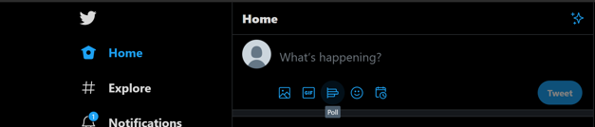

Step Two: Edit the poll
Be creative and ask questions with substance. The most important part is retaining customer feedback. “what’s better dogs or cats” is too generic. Try something like “Spice pumpkin latte or dark mocha frape”.

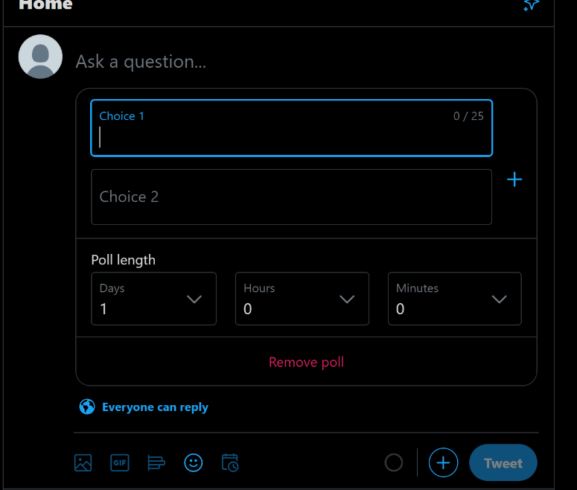

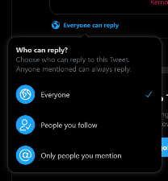
Step Three: Choose your audience
Set the post visibility to everyone for maximum interactions. If it’s a bit more personal set it to followers only. This will make it so fans/followers voice is heard over potential filler.

